Senior Advocacy and Public Affairs Manager
Full Time (35 hours per week)
Salary £44,478 per annum
Permanent

Thank you for your interest in Museums Galleries Scotland (MGS). Please find below information about working at MGS; and a job description for the post of Senior Advocacy and Public Affairs Manager.

To apply:
- Please complete an application form, by downloading it from our website at: http://museumsgalleriesscotland.org.uk/jobs

- Then submit your form via our online system at:

https://hr.breathehr.com/v/senior-advocacy-and-public-affairs-35179

The deadline to apply is Monday 13 May @ 9am

Please use our application form, CVs will not be accepted. If our application form makes it difficult for you to apply and demonstrate your skills effectively, we would be happy to accept a video, audio or alternative application format. Please refer to the guidance on alternative application format to ensure your application will cover all the required information. If you would like to discuss an application in an alternative format, please contact us on the email below or call 0131 550 4197.
If you have any queries please email hr@museumsgalleriesscotland.org.uk, including the name of the post in the subject box.

Please note that interviews for this post are planned to take place online, in the week commencing 27 May 2024. The format of the interview will be a task or presentation which we will send information about in advance (if relevant to the role) and a series of competency based questions.

Museums Galleries Scotland welcomes applications from all sections of the community and is an equal opportunities employer. We hold Living Wage and Investors in People Gold accreditation and are happy to talk flexible working. We will guarantee an interview to people with disabilities who meet the essential criteria in our person specification.

Please note that details supplied may be held in electronic and paper files for administration purposes only during the recruitment process. We retain recruitment files for six months following the date of interview, after which they are disposed of appropriately. You can find our privacy policy here: http://museumsgalleriesscotland.org.uk/privacy-policy/

Working at Museums Galleries Scotland
Museums Galleries Scotland is the National Development Body for the Scottish museums sector. We’re here to support more than 400 museums and galleries, whether through strategic investment, advice, advocacy, skills development or other means. You can find out more about our objectives, business plan and day to day goals on our website: https://www.museumsgalleriesscotland.org.uk/about-us/
MGS currently has 37 staff. We have Gold Investors in People accreditation, are a Disability Confident Employer and a Living Wage Employer. MGS is striving to be an anti-racist organisation and more information on our commitment to this is here. We also aim to support museums and galleries to reach their climate and sustainability goals and our commitment to climate action can be found here.
Location
MGS is a hybrid working organisation with flexibility around working from home and the office. We have a modern open-plan office in central Edinburgh and we are set up for a range of flexible working options.
There is no expectation that staff will attend our office for any set number of days per week or per month. Depending on the role, we are also open to the option of ‘homeworker’ status where an employee is based at their home address.
The postholder may be required to attend certain events, in-person meetings and to make visits to museums as necessary. However, with most roles, we are open to discussing the frequency of this with the successful candidate.
We also hold quarterly ‘all staff’ meetings which we do expect everyone to attend in person wherever possible. Examples of recent meetings have included a trip to the Scottish Crannog Centre and to the Edinburgh Printmakers.
In order to carry out an effective induction, we consider it beneficial for the successful candidate to attend our Edinburgh office on your first day of work at MGS.
Hours of work
The normal full time working week is one of 35 hours (from April 2024) Monday to Friday with a minimum unpaid lunch break of half an hour.
Annual leave
Annual leave entitlement for full-time employees is 25 working days plus 10 public holidays, rising to 30 days after 5 years’ continuous service. (Leave is calculated pro-rata for part-time employees.)

Pension
MGS employees will be automatically enrolled in the Lothian Pension Fund.
Employee Assistance Programme
All employees have access to an Employee Assistance Programme offering support on a wide range of issues.

MGS is commited to progressive changes across our ways of working and to continuous improvement. We are proud to have achieved or signed up to the following organisational accreditations and commitments.

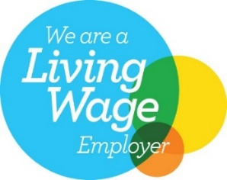
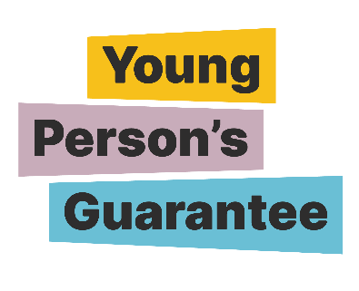
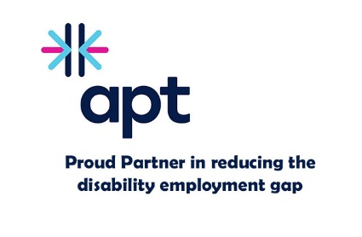
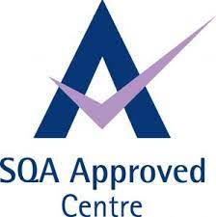
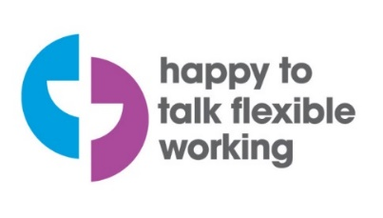

[Logos shown are for: Investors in People Gold, Happy to Talk Flexible Working, Living Wage Employer, Disability Confident Employer, Apt – Proud Partner in reducing the disability employment gap, Carbon Literate Organisation Gold, SQA Approved Centre, Young Person’s Guarantee, Modern Apprenticeships provider, Scottish Business Pledge.]

Pension: employer contribution 19.4% in 2024-25

Senior Advocacy and Public Affairs Manager
Job description

Job information
- Line manager: Head of Strategy and Communications

- Team: Marketing and Communications

- Full Time (35 hours per week)

- Permanent Post

- Location: Hybrid

SUMMARY OF POSITION
The Senior Advocacy and Public Affairs Manager works with the Head of Strategy and Communications to develop and maintain awareness of the value and impact of the museums and galleries sector.

You will do this by developing and leading advocacy campaigns and activity that make a strong case for Scotland’s museums and galleries sector to influence a range of audiences and stakeholders including Government Officials, Government Ministers, MSPs, relevant Committees, relevant funders and other key organisations and influencers.

Politically astute, the Senior Advocacy and Public Affairs Manager possesses strong communication and influencing skills, using information, research and data to build a political and public case for the sector and inform evidence-based advocacy messaging and activity. Being able to navigate and effectively communicate complex issues that implicate the wider culture and heritage sector in Scotland will be essential. The postholder will display energy and enthusiasm in their interactions with others; be able to see the bigger picture and communicate effectively with a range of different audiences to positively shape how people view the museums and galleries sector.

Collaboration will be a key part of how you work as you maintain positive relationships with the Scottish Government and your counterparts in key partner organisations. You will work closely with the Senior Management Team to identify and act upon sector issues and with the Marketing and Communications team to communicate and involve the sector in advocacy opportunities. You will also maintain awareness of work carried out internally across the organisation to bolster strategic advocacy opportunities, for example on skills and workforce development.

OVERVIEW OF RESPONSIBILITIES
Strategic
- Work with the Head of Strategy and Communications and Senior Management Team to develop advocacy and public affairs strategic plans and messaging that meets MGS’s strategic priorities
- Develop and maintain relationships with key stakeholders to ensure strong MGS and sector profile and reputation
- Contribute to the delivery of the National Strategy for Scotland’s Museums and Galleries and ensure strong awareness of the strategy among key political stakeholders and policy makers
- Contribute to the development and delivery of MGS’s Business and Operational Plans, reporting on progress as required
- Lead on the coordination of the MGS led Scottish Museums Advocacy Group quarterly meetings
- Work closely with a policy network of MGS culture and heritage sector partners to help inform and develop aligned advocacy across organisations
Communications
- Lead on the delivery of Advocacy and Public affairs plans and activity with Marketing and Communications team, wider MGS and sector colleagues
- Communicate the views of MGS to legislators in the Scottish and UK Parliaments, local government and other external organisations, either directly or through joint working with strategic partners to influence decision making
- Lead on MGS’s responses to relevant public consultations co-ordinating with relevant sector partners and MGS colleagues
- Communicate MGS’s advocacy work to the sector through relevant channels including writing content for news items, newsletters and blogs
- Prepare briefings for Ministers, MSPs and Civil Servants in response to sector related matters
- Lead on briefings and speech notes for the Chair, Chief Executive Officer and senior managers for major events and key engagements that reflect sector advocacy messaging and maintains profile and engagement with the sector
Research and analysis
- Oversee and maintain timely monitoring of Parliament, Government, stakeholders, press and media on relevant policy developments in the museums and galleries and wider culture sector and brief MGS colleagues on relevant activity or issues
- Maintaining an understanding of current political priorities within MGS, making opportune connections to the work of the sector and MGS colleagues. Provide advice and guidance, both internally and externally, on relevant policy matters
- Work with Senior Management Team to maintain awareness of museums who are experiencing challenges; coordinating MGS’s response and supporting other organisations with response development when necessary

- Work with the Research Manager to develop advocacy opportunities and messaging from findings from MGS or externally led pieces of research

RELATIONSHIPS
- Build and nurture effective working relationships across the organisation and be part of an effective Senior Management Team
- Advocate on behalf of the sector and MGS and including representation to key external stakeholders and the Scottish museum sector as a whole
- Collaborate with other staff to identify and deliver opportunities to profile the work of the sector and MGS
- Work fairly and with integrity and adapt style to different people, cultures and situations

People Management

- Work with Marketing and Communications Head and Managers to provide collaborative leadership of the Marketing and Communications team, supporting efficient allocation and prioratisation of resouces.
- Provide support and recognition to staff and understand the needs and concerns of the team
- Take responsibility for development and motivation of staff, ensuring skills and strengths are used effectively
- Support on aspects of staff performance development and management process
- Undertake line management responsibilities as required

Person Specification
The successful candidate will manifest our core values: collaboration, integrity, passion for museums, and courageousness.

EXPERIENCE AND SKILLS
Essential
- Significant experience gained working in an in house or agency Advocacy and Public Affairs Role or similar for example Public Relations or Government Affairs
- Politically astute with strong knowledge of the Scottish political system and priorities
- Experience of leading advocacy or awareness raising campaigns or activity designed to meet a need
- A strong understanding of policy development and influencing policy decisions
- Excellent written and oral communication skills
- The ability to clearly and effectively communicate complex issues to a range of audiences
- Confidence using a range of digital platforms

Preferred
- Experience working with or in Scottish Government
- Experience of working with the Scottish or UK press
- People management experience
- Experience or knowledge of the museums and galleries, heritage or cultural sector
- Commissioning or using research findings in advocacy work
- Campaign measurement, evaluation and reporting
- Understanding and managing risk

HOW YOU WORK
MGS has a behavioural competency framework which describes how we expect people to go about their work day-to-day. Staff must demonstrate the following skills areas at an appropriate level:
• Works collaboratively
• Communicating with impact
• Respect, inclusion and integrity
• Effective decision-making
• Sector focus
• Drive for results
• Innovation, agility and building capability
This role requires someone who displays energy and enthusiasm in their interactions with others; communicates effectively with and is approachable to a range of different audiences and can positively shape how people view the museums and galleries sector. As a member of the Senior Management Team you are expected to act as a role model for MGS’s organisational behaviours and to champion the organisation internally and externally.
All staff are expected to champion and help deliver MGS’s commitments to anti-racism and climate.
SPECIAL REQUIREMENTS – Travel – occasional regional travel may be required.

