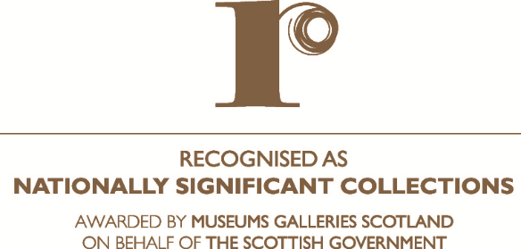

**Note of Interest**

**2025 - Round 16**

**- From a single organisation**

**- On behalf of a partnership**

*Please delete as appropriate*

*Please note the form should be completed using 12pt font and single line spacing.*

|  |  |
| --- | --- |
| **1. Name and address of applicant organisation** (*or coordinating partner in the case of a partnership application*)**:** | |
|  |  |
| **Address:** |  |
|  |  |
| **Email:** |  |
| **Main contact for note of interest:** | |
| **Name:** |  |
| **Job Title:** |  |
| **Address (if different from above):** |  |
| **Telephone:** |  |
| **Email:** |  |

|  |  |
| --- | --- |
| **2. In the case of a partnership applications** *please list all the partners.* | |
|  | |
| **3. Name of proposed collection** | |
|  | |
| **4.** Please provide a **brief summary description of the collection** you will be applying for. Please refer to sections on *What to apply for* and the *Definition of collection for the purposes of the Recognition Scheme* in the Applicant Guidance. *(You should submit no more than 250 – 300 words)* | |
|  | |
| **5.** Have you considered this collection in light of the **Recognition Criteria** as published in the Applicant Guidance? Please identify any specific aspects on which you would like further guidance at the Applicant Workshop. | |
|  | |
| **6.** Have you considered this collection in light of the **evidence requirement and supporting information** you will need to provide, as published in the Applicant Guidance? Please list specific aspects (if any) on which you would like further guidance at the Applicant Workshop. | |
|  | |
| **7.** Are there other aspects of the application process on which you would like further guidance at the Applicant Workshop? | |
|  | |
| **8. Declaration** | |
| I declare that I have considered the collection in the light of the requirements to apply for recognition as described above, and intend to submit an application into the **2025** **Round** of the Recognition Process. | |
| **Signed** |  |
| **Name** |  |
| **Position** |  |
| **Date** |  |

|  |  |
| --- | --- |
| *Please submit by* ***5pm*** *on* ***Friday 30 May 2025*** *to:*  *Jacob O’Sullivan*  *Museum Development Manager – Collections & Interpretation*    *Email:* [*jacobos@museumsgalleriesscotland.org.uk*](mailto:jacobos@museumsgalleriesscotland.org.uk) |  |