

**Leisure & Culture Dundee**

**Nationally Significant Collection status Review 2018**

**Name of Nationally Significant Collection: Whaling Collection owned by Dundee City Council and managed by agreement by Leisure and Culture Dundee, objects displayed in but not limited to The McManus, Mills Observatory and Broughty Castle Museums. This will also include the museum out stores and Collections Unit.**

**Name of governing body: Leisure & Culture Dundee**

In response to the letter dated 26th November 2017 for the Recognition Committee to review the Recognised status of the Whaling Collection cared for by Leisure and Culture Dundee, please find the report detailing why the collections should retain its current status. The report covers the main points raised in the guidance, if any further information is required please do not hesitate to contact us.

1. **Are the collections still eligible?**

Our whaling collection crosses traditional subject distinctions. Made up of whaling equipment, journals, models, paintings, scrimshaw, natural science, Inuit material and photographs. It relates to the history of whaling and brings it up to date with the inclusion of explosive harpoons and modern practice. The collection attracts attention from local, national and international audiences and is used by researchers again locally, nationally and internationally.

The collection is displayed at Broughty Castle Museum and in The McManus: Dundee’s Art Gallery and Museum which had a major redevelopment and opened again in 2010. The Famous Tay Whale was displayed once again in the museum as a centre piece to a multi-disciplinary display of whaling material to fully explore the story of Dundee’s Whaling history.

A grant from Museums Galleries Scotland allowed for expert advice to be bought in to assist with the interpretation which is still used in the gallery today.

We have links with Hull not only in the historic sense that we both had major whaling industries and our collections complement each other, but also by the long term loan of our polar bear which has become a much loved symbol of the city museum.

The collection is used regularly by researchers for private and scholarly research by local, national and international audiences. There is still a demand for access to these collections and they remain some of the most important material which relates to the whaling industry in Scotland. Along with Jute, Journalism and Jam, Dundee’s other major industries were built around the access to the river. In the late 18th and 19th Century’s Dundee became Britain’s largest whaling port. Whale oil was used in the production of Jute. As industry in the city grew so did its wealth. The industry’s demand for whale oil helped stimulate the declining whaling industry, by the latter half of the nineteenth century Dundee was the premier whaling port in Europe.

Our whaling collection includes some of the most important evidence of the industry in the UK. It shows the major industry within the city and the compilation of this collection supported other industries within the city. This can be seen with the Recognised Collections of Verdant Works and our own Nationally Recognised Whaling collection.

The long term loan to Hull Museums and the historical background along with the supporting collection goes some way to show that Dundee not only made its place in the world it is still relevant and connected today.

**The collection still meets and goes beyond the scheme objectives:**

* 1. **To raise awareness and appreciation of the Recognised Collections, maximising their potential to celebrate Scotland's culture - locally, nationally and internationally.**

The Whaling collection remains a relevant part of our collection, even though it is a hard story to hear and may not be a subject that we all want to speak about, the industry still remains a major part of Dundee’s make up. It is not only the industry itself, it was the knock on effects that it had on the city and the surrounding areas. The Recognised collections status has allowed the collection to be shown, explored and researched on a local, national and international level.

The redevelopment of The McManus: Dundee’s Art Gallery and Museum raised awareness of the city’s collections in the city, across Scotland and wider. The McManus was voted Dundee’s favourite building and remains at the heart of the community simply because we show, interpret, question and engage with what is relevant to the city. The status has also had an impact along with The Accredited Status. The Tay Whale remains a much loved centre piece to the Making of Modern Dundee Gallery and the museum itself and gives an easy to understand introduction to the subject.

In the past 6 years we have had over a dozen requests for images of photographs, journals and photographic copies of objects in the collections for publications, books and TV programmes. Some of the requests are international but the majority remain on a national UK level, this remains proportionately high for the collection area. In 2014 KEO films were commissioned by the BBC to make a documentary on whaling and used a large number of images from The Recognised Collection.

Dundee City Council and Leisure and Culture Dundee have given significant funding to purchase a new collections management system which is fit for the demands of the digital age, with a built in Digital Asset Management System (DAM) it will allow (in time) all of the collections related information to be stored in one location, elements will also be released online via a collection online portal to allow the public to better explore and appreciate the city’s collections. We have now migrated the old CMS and continue with discrepancy checking, migrating the tens of thousands of images and beginning a process of enriching records to move beyond the basic accreditation standards. We continue to work with other partner users of KEMU (CMS) across Scotland and have shared our experience of the succession planning project which has brought together collections documentation into easy to use, searchable and user friendly records which will be the base line for all records in the CMS.

*“Thank you so much for taking time on Thursday to have a chat. It was really interesting to see what you’re up to and the succession planning project sounds like the sort of thing which is the envy of the entire sector”.*

*Nico Tyack, Information Officer, Edinburgh City Council.*

In 2017 we received 15 formal museum enquiries with regard to the whaling collection, the vast majority of those enquiries led to the enquirer coming to the Collection Unit to have facilitated visits with the collections.

The collections have also been used as inspiration for artists, who have used the collections to inspire digital and textile art works. Collections have been used in facilitated drawing sessions for projects at Duncan of Jordanstone School of Art, The Edge Textile group, along with our own friend’s organisation The 168 group who used the Tay whale as inspiration for one of their workshops. We continue to facilitate the frequent requests for researchers for both provided information and access to the collections themselves. Previously funded projects have allowed more efficient access to frequently asked questions and further research internally and by external researchers allow the collections to remain relevant and develop.

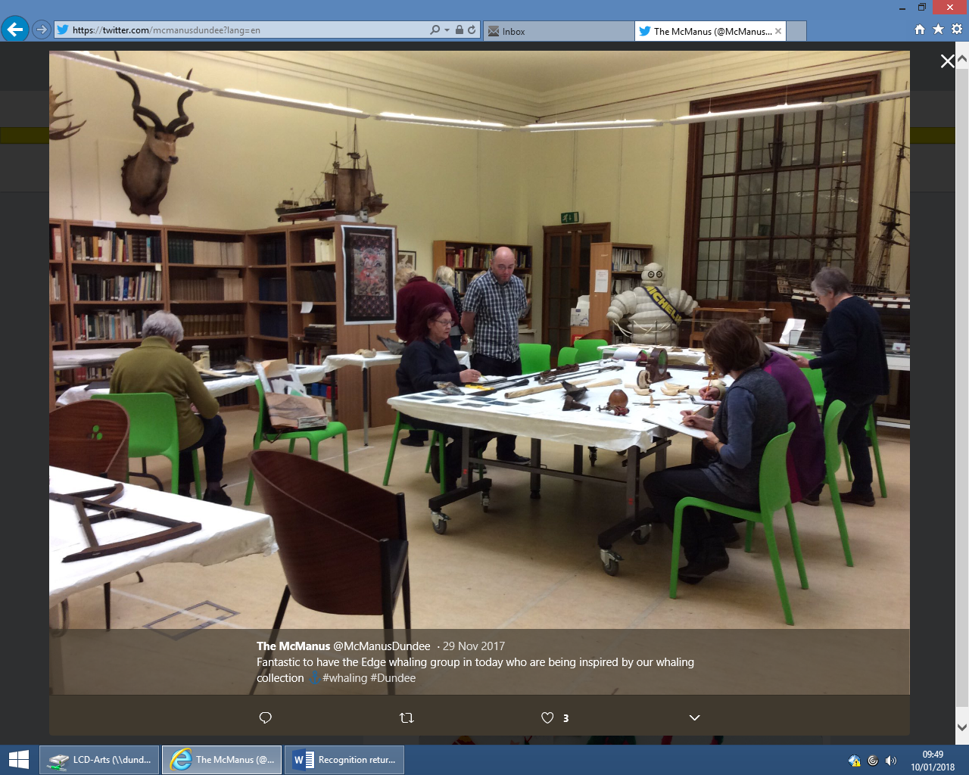

The Edge Textile group working in The Collections Unit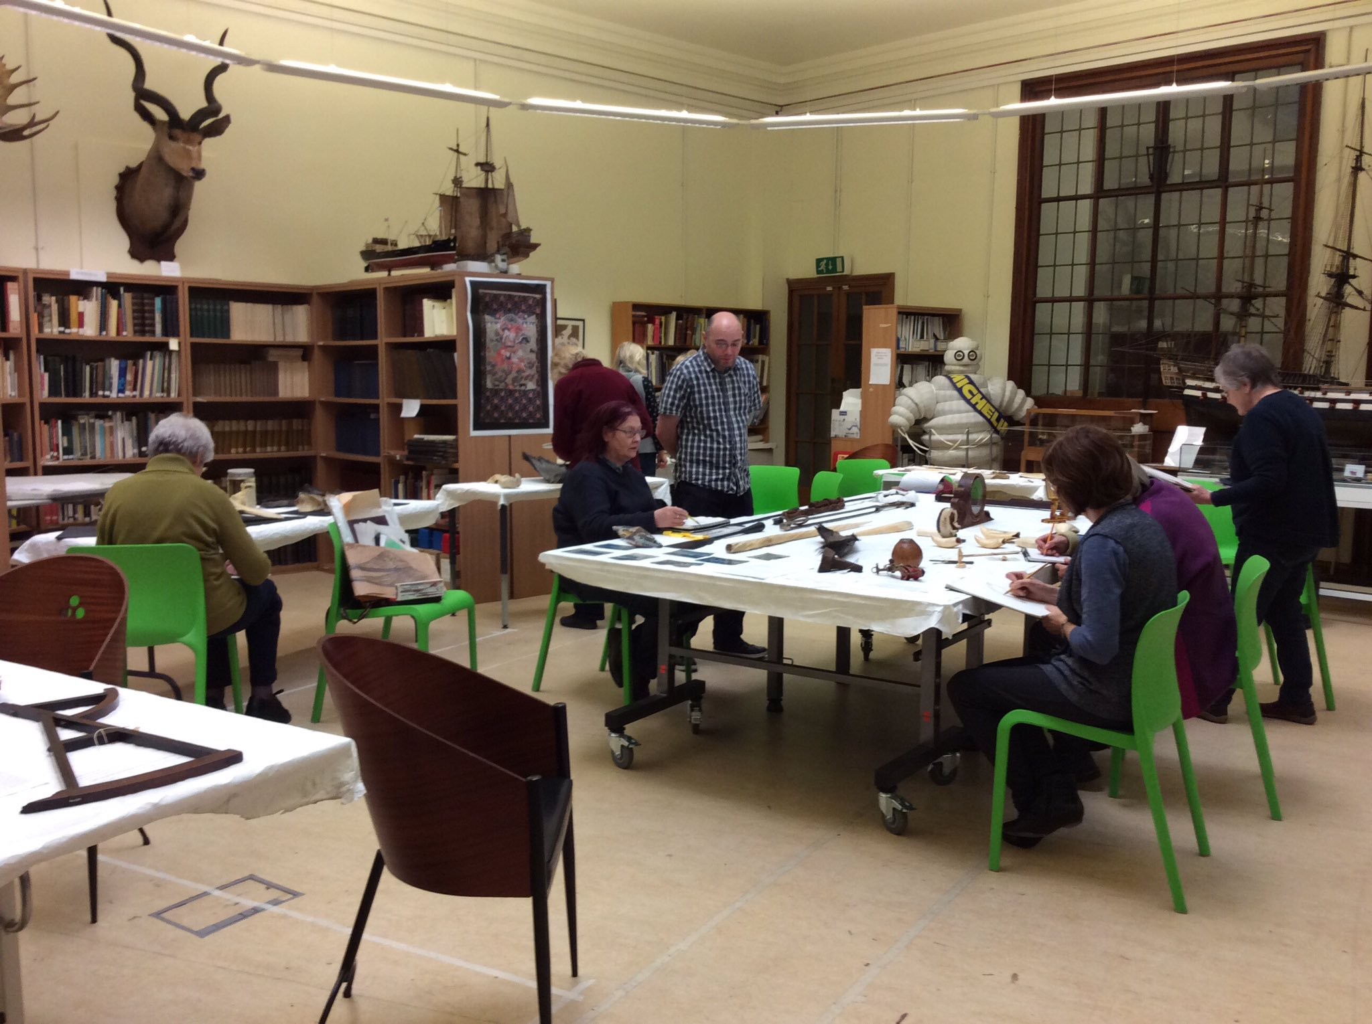

The Tay Whale has also featured as a centre piece to the McManus 150 years celebration and an almost life size image of the whale is bedecked on one of Dundee’s city buses. It has also captured the imagination of the city wide “The Peoples Story” project which used the Tay Whale as inspiration for the people’s textile (a textile woven over the period of the 150 celebration).

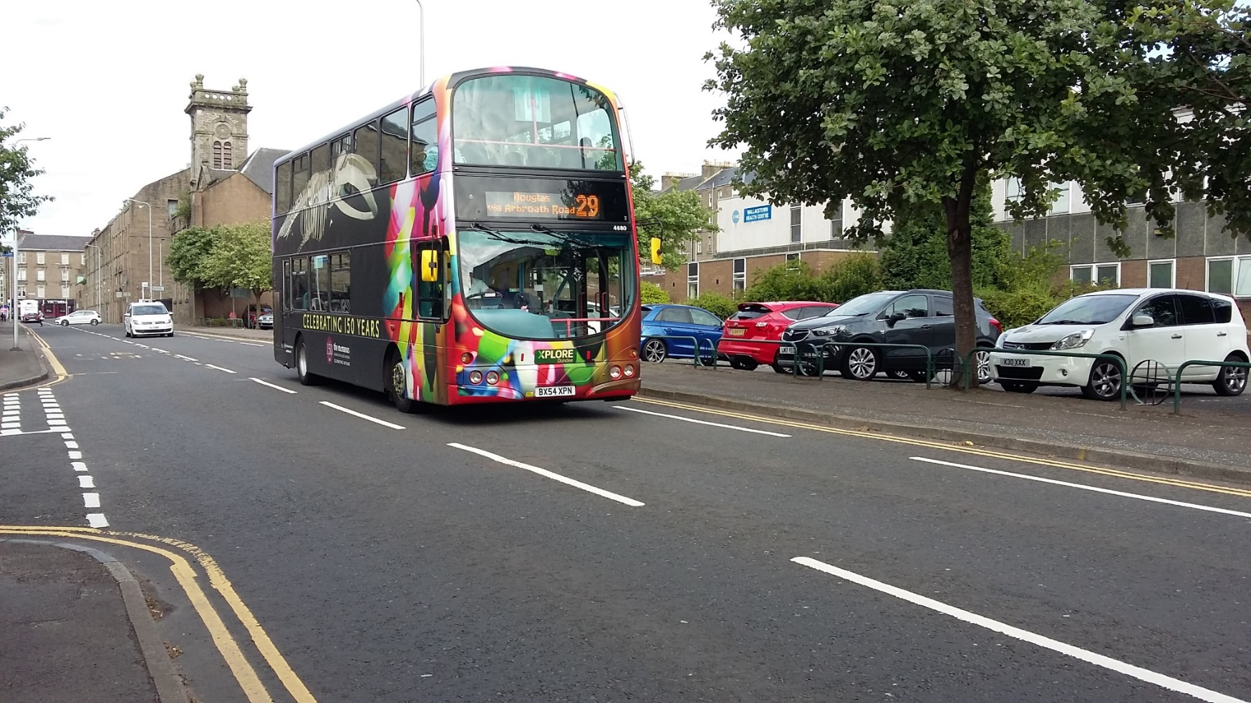

The Museums 150 Celebration bus livery

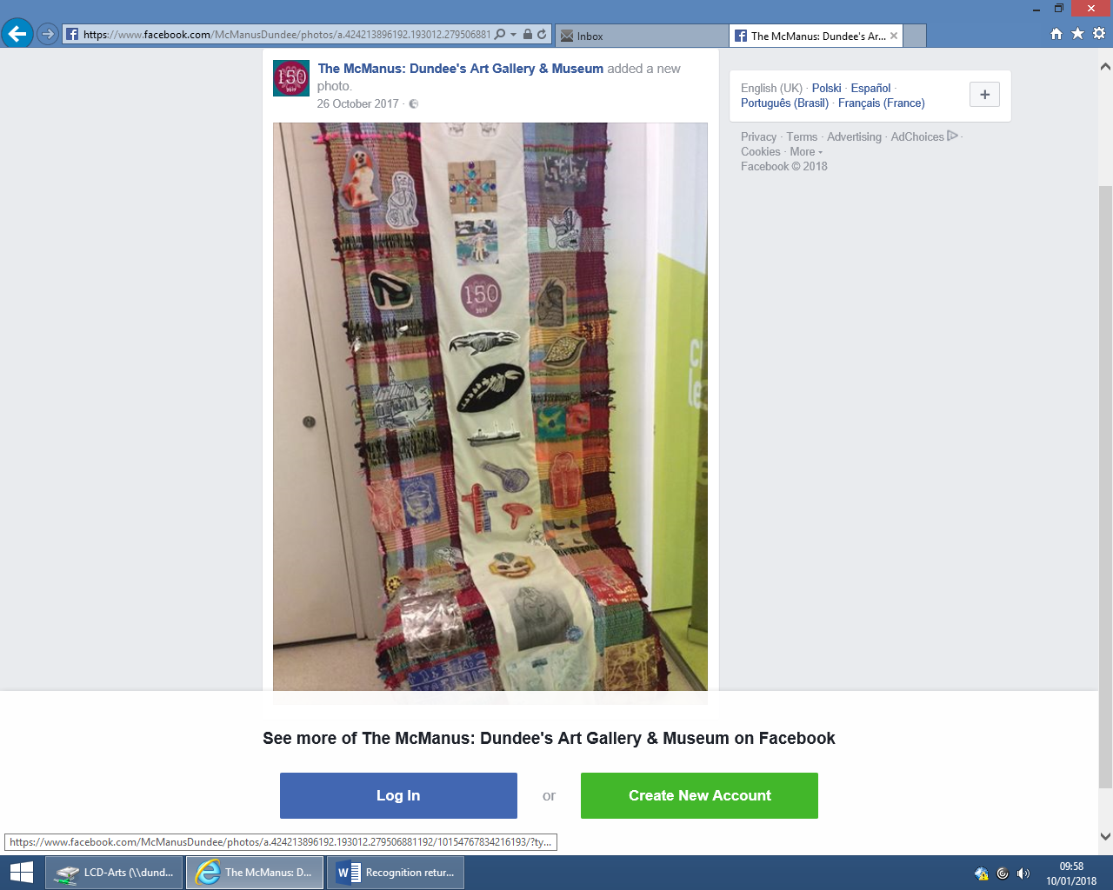

The peoples textile with Tay Whale

**1.2. To ensure the longevity of Recognised Collections by raising standards in collections care and management.**

The recognised collections cut across traditional subject distinctions, cared for in principle by Julie McCombie- Curator of Social History (23 hours per week) but as cross sectional also by Michael Sedekat – Curator of Natural Sciences (Botany and Zoology vertebrates (18.5 hours per week)) and Christina Donald – Curator Early History (F/T but responsible for Archaeology, numismatics and world cultures including Inuit material).

Julie joined the organisation in 2016 but has prior knowledge of the whaling industry in Dundee and is being given time to increase her knowledge of the subject area with support of industry specialists, researchers, previous projects and from the support of colleagues and researchers.

The introduction of the new collections management system and a plan to move beyond accreditation to fully document the collections has allowed curator to spend more time with collections, since award we have also invested in a number of short term contracts which have added to the documentation of the collections.

We are now working towards fully digitising the collection which will include whaling photographs, journals, objects, Inuit material and individually numbering bulk accessioned objects which will give greater access via our collections online, this is of course building on the already digitised material.

We work with other users of KEMU across Scotland to share sector knowledge, and remain an active member in the Tayside Museums Forum.

The collections were decanted from The McManus as part of the redevelopment and rehomed in the Collections Unit, a dedicated collections storage facility in centre of the city. The whaling collection is dispersed throughout the building in different stores which all meet current industry standards in collections care.

We have a dedicated object conservator who monitors the environment, carries out regular pest checks with an integrated pest management regime and the natural science curators make additional checks on vulnerable materials such as the whale bones, and preserved specimen.

We aim to digitise and transcribe collections not only to give better access to collections but to also limit their handling and movement from storage. All access to collections is fully facilitated to ensure standards in collections care are upheld and to provide best quality visitor experience.

We also aim to use social media to raise awareness of the collections and have spent time over the past year documenting the long-finned whale and have captured this via Facebook, twitter and Instagram.

Our 150th Celebration year summer show called ‘Dundee Preserves’, a play on one of the three J’s looks at the work of our curators and collections care team and showcased a multi- disciplinary show to explain the work that happens to care for, document and research the city’s collections. A main feature of the exhibition is our Walrus, donated by: Captain W., Adams (S.S.'Arctic'),1878, which is part of the recognised whaling collection.

Also displayed as part of this exhibition was an early whalebone corset, the only one in the collection. A linen whale bone corset from the late 18th century which was purchased by the museum sometime closely after 1800 for 5 shillings and 8 pence. The corset has been conserved and is displayed mounted on a bespoke mannequin.

**1.3 . To strengthen resourcing for the long term sustainability of the Recognised Collections.**

After the sudden death of David Henderson, (our curator and world expert on whaling) in 2005, much of the collections knowledge was lost. To prevent this happening again and to assist with the increased demand in enquiries, collections knowledge and to aid succession planning we applied to Museums Galleries Scotland for a grant through the Recognised Collections Fund.

In 2009 we were funded for a project to employ a project coordinator to work with a number of organisations across Dundee to ascertain what resources were available with regard whaling and bringing together this information in an accessible and easy to understand format.

A number of databases were created to capture this information. Additional information was added to our collections management system, along with a number of images from the whaling collection.

This project gave a firm foundation allowing us now as part of our retrospective documentation strategy to fully document the collection having all information in one accessible format. We now have a new collections management system will which have the capacity to link the work undertaken in this previous projects to our future documentation plans.

This project and the future projects have and will allow better, quicker and more sustainable access to collections information for researchers, enquirers and our own curatorial staff.

With a proven demand for access to collections and knowledge in 2013 Museums Galleries Scotland funded a publication which set out to use items from the Recognised Whaling Collection and presents them to the public directly. The publication used prior knowledge of the project coordinator Malcolm Archibald, our curatorial team and industry experts along with the images from the Recognised Collection to produce ‘Ancestors in The Arctic.’

The publication has assisted in raising the profile of the collection along with increasing access to the collection through visits, research and enquiries. This in turn has increased the sustainability of the collection as we can demonstrate demand and support through an increased sense of public ownership. The publication is widely available and demand remains steady in the museum shop, online retailers and local book shops.

Corporately Leisure and Culture have a charging policies for image reproduction and enquiry services allowing an initial 30 minutes free of charge. Funds brought in via sales of images to publications, TV/ Film and by additional enquiries is put back into the care of the collections. We anticipate that the new collections management system will give easier access to image reproductions.

**1.4. To inspire and deliver new forms of access to and public engagement with the Recognised Collections.**

In 2017 The McManus: Dundee’s Art Gallery and Museum celebrated its 150th birthday, a major advertising campaign and a liveried bus was a big draw, particularly noticed across the city with the near life-size image of the Famous Tay Whale which has become an unofficial symbol of the museum.

The whale was also used for inspiration for the people’s textile as part of the museums “People’s History” project which ran though the 2017 celebrations.

The Dundee Preserves Exhibition featured a much loved and well-remembered (previously on display in the old Barrack Street Natural History Museum) walrus from the whaling collection. The labelling referred to the Recognised Collections. As part of the exhibition and to raise public awareness we asked for suggestions to name the walrus, after receiving many 1000’s of suggestions an overall winner was chosen, she was given the name Marmalade.

Involvement with the Festival of Museums in 2014 allowed us to trial a new delivery method. The McManus was opening for an evening, with staff and actors providing factual information, entertainment, and a connection to the museum objects for visitors. Although many topics were included in this event, whaling featured as the responsible curator made some objects available that are normally not displayed, and was also available to discuss these with visitors. One of the characters brought to life was Captain Fairweather, a local whaling captain.

The previously Museums Galleries Scotland funded projects, the new collections management system and its online derivative, The McManus redevelopment, internal and external research, curatorial staff and our dedicated proven program of public engagement continues to inspire and educate our audiences old and new, the esteem that comes with the award helps support and bolster the other collections.

**1.5. To support holders of Recognised Collections to increase their leadership of and contribution to the sector through innovation, ambition, collaboration and partnership working**

The Museums Galleries Scotland funded project “Dundee Whaling History” worked in partnership with four organisations with like material within Dundee. The project employed a project officer who created a database of information to make the collection more accessible, easy to find and create a mutual understanding of each other’s collections among the partners. The initial feedback from the project was that all participants valued the project highly and appreciated its simplicity and ease of participation. It led to enhanced mutual understanding between colleagues and collaborators, and enabled Cultural Services staff to have a better awareness of the context of their own collections and how the content of these relates to the other collections in Dundee.

An additional partnership emerged unexpectedly during the project, with the University of Abertay which has used the Whaling Collection as inspiration for students on the Computer Arts course.

Latterly Museums Galleries Scotland on the success of the above project funded the publication of Ancestors in the Arctic, a publication of stories and images from the recognised collections again collaborating with national expert Malcolm Archibald.

Leisure and Culture Dundee continue to work in partnership with external partners who use the collections for research for publication, TV and academic. This not only enhances our knowledge of the collections but reinforces the status, allows Scotland to show its history and ambition to a national and international audience.

1. **Have there been any major additions and/or disposals since Recognition status was awarded and how have these affected the importance and/or quality of the Recognised Collection.**

Leisure and Culture Dundee on behalf of Dundee City Council are actively collating material to enhance, enrich and develop the recognised collections. As to be expected with an industry which is no longer active and is of course of a sensitive nature material is seldom available.

Over the past 10 years passive collecting has been the main in routes to the collections along with some considered purchases. Support from the National Fund for Acquisitions has enabled larger purchases such as the Terra Nova model and the Burn Murdoch painting.

Our curators actively searches material for sale which could be added to the collection. We are selective to which material is added to the collection and cross reference the material which exists in the local history library and the city archives.

There has been no material disposed of from the collections.

Below is an extract from our collections development policy and a list of material which has been added to the collections since award.

*“5.4.4 Working Life*

*Active and passive collecting will be undertaken for the following categories:*

* *Agriculture, forestry and fishing*
  + *Falling into this category is the whaling collection which is a nationally significant collection, designated by Museums Galleries Scotland on behalf of the Scottish Government. It is unlikely that many donations will be made to enhance it. Therefore passive and, where possible, active collecting will be applied where an object in question will enhance the collection.”*

**2.1 List of acquisitions:**

2008-80 Wall mounted telephone from the old whaling workshop in East Dock Street.- Donation

2010-73 Book containing Toshie, a play in two acts, by Stewart Brown. Toshie is based on an episode in the remarkable life of James McIntosh, a Dundee whaler. Contains details about the Dundee Whaling Industry. The play was first performed at the Dundee Repertory Theatre in 1994 and ran from May 6th to 28th. - Donation

2010-27 Blanket made from eider duck skins by the inuit for Captain Milne of the whaler Eclipse. - Donation

2010-86 Black and white postcard showing the S.S. Terra Nova in the dock. Men working on and beside the ship in a small boat. - Donation

2011-28-1 School jotter. Title on front is "The Arctic and the Antarctic" ,contains work on school project on Dundee Whaling. - Donation

2012-105-1 Black and white whale toy - donation

2012-64-3 Black and white photograph of Balaena whaling ship. Believed to have once been used as a whaling ship in Dundee (1891 - 1914).

2012-65 Builder's half model of the ship Terra Nova. Purchased from Bonhams Polar Sale: Scott and Amundsen Centenary, Sale number 19552, London, Knightsbridge on 30th March 2012.. Purchased with 50% funding from the National Fund for Acquisitions (NFA). On the model itself it reads: 'Terra Nova The Dundee Shipbuilding Co Ltd.'

Terra Nova was built by the Dundee shipyard of Alexander Stephen and Sons Ltd, managed by William Stephen, and was launched in 1884 for the Dundee Whaling and Seal Fishing Fleet. At 187ft. (57m) long, she was specially strengthened for hard use in the Polar ice and she spent the first ten years of her life working in the Labrador Sea.

The British Antarctic Expedition bought the vessel in 1909 from Bowring Brothers and, reinforced with 7ft. of oak, she sailed a year later under the command of Captain Robert Falcon Scott to the South Pole. Following the tragedy of Scott and his companions, Terra Nova returned to the UK in 1913 and was re-purchased by Bowring for the Newfoundland fishery. Purchase

2012-64-2 Ship model of whaling ship 'Balaena.' A plaque on the bottom of the ship stand reads ' Built Drammen, Norway, 1872. Dundee Whaler 1891-1914, Henry Nairn, Carpenter, circa 1906'. -Donation

2013-144 Ivory carving (Sacred heart) carved by a whaling captain. Donation

2013-110-1 Certificate of Discharge for Charles C. Grant on the whaling ship 'Cornwallis'. Small slip of paper listing Charles C. Grant as the Surgeon on the Cornwallis. He was 21 and born in Liff. Place and date of engagement was Dundee 11/03/1885 and the place and date of discharge was Dundee 21/08/1885. Charles' character for ability and for conduct are stamped 'V.G'. It is signed by Master John Nicoll. Donation

2013-110-3 Lose sheets relating to voyage of the whaling ship 'Cornwallis' 1885. 64 lose sheets - some cream-yellow colour, others on blue paper. Begins 'In early April of 1885 the whaler Cornwallis left Dundee...' Donor believes this account was written by the ships surgeon Charles C. Grant. Donation

2013-110-2 Account of Wages for Charles C. Grant, Surgeon onboard the whaling ship 'Cornwallis' 1885. Document shows Charles was on board for 3 months and 11 days, for which he earned £10148. With deductions of £2149 he was paid a total of £71911. Donation

2013-4 Small watercolour of the 'Dundee Whaling Expedition' by W. G. Burn-Murdoch.

Painting of the Dundee Antarctic Whaling Expedition in watercolour showing three ships; Active, Diana and Balaena moored to an ice-flow with large bergs in the background. Entitled Scottish Whaling Antarctic Expedition 1892-93 by W G Burn-Murdoch. %0% funding through The National Fund for Acquisitions. Purchase

2016-49-2-1=88 Photograph album, images taken aboard the Diana c1900. There are 48 images. Loose in the back of the album are a further 39 images and a hand written note. Donation

2016-49-1-1 Photograph album, images taken aboard the Diana c1900. There are 48 images in total. Donation

2016-75-1 Gavel, wooden handle with a Sperm whale tooth head. Donation

2016-53-11 1 of 14 certificates of discharge for seaman James Reid, 32, Dundee. Description of Voyage or Employment Sealing and Whaling. Date of engagement 09/02/1889. Date of discharge 06/11/1889. Place of discharge Dundee. Donation

2016-53-9 1 of 14 certificates of discharge for seaman James Reid, 34, Dundee. Name of ship Yerra Nova. Sealing and Whaling. Date of engagement 09/02/1888. Date of discharge 02/11/1888. Place of discharge Dundee.

2016-53-8 1 of 14 certificates of discharge for seaman James Reid, 31, Dundee. Name of ship Yerra Nova. Sealing and Whaling. Date of discharge 24/10/1886. Place of discharge Dundee.

In 2002 David Stockdale, who previously curated the whaling collection and considered a world expert, was promised upon the donors death a collection of books dedicated to whales and whaling collated by a professor who had studied whales and whaling. The 93 book strong library contains many rare and out of print books relating to the discipline. In 2016 the donor contacted the museum to discuss the bequest and was so impressed by our new curator Julie that he decided that he would like to gift the collections before his initial intention. After much discussion the library was donated to the collection but remains part of our research library to allow greater access for public engagement and have therefore not been accessioned formally in the permanent collection.

1. **A description/outline of the curatorial provision for the collection and whether this has changed since Recognition status was awarded.**

At the time of application two experienced curators, Fiona Sinclair Heritage Officer (Community History) and Rhona Rodger. Heritage Officer (Social History) were responsible for the collections.

In the intervening year’s staff provision, organisation structure and responsibilities has changed. Fiona Sinclair was appointed as Museum Service Section Leader following The McManus redevelopment (reopening 2010), and a number of early retirements, there was a major restructure of Cultural Services, and “Leisure & Culture Dundee” was born as a SCIO.

At that point Fiona became responsible for overseeing the Archaeology, History, Natural Sciences, and World Cultures collections and associated Curators (initially 2 x Nat Sci, 1 x Arch & World Cultures, 1 x Social History), and the Conservator and the Museum Registrar. In 2013 we gained an additional Curator of Social History.

Fiona also had responsibilities for overseeing Broughty Castle and The Collections Unit along with stand in duties for Head of cultural Services. Fiona no longer had a curatorial remit.

Rhona remained the Social History curator with responsibility for the social history collections including at the time Industrial history (textiles, printing, trade unions), Maritime (whaling, shipbuilding, fishing, navigation), Warfare and Defence (navy, air force, army, civilian life), Engineering (mechanical, electronic, refrigeration, machinery), Transport (roads, railways, ferries, air).

In 2011 we were successful in gaining a Museums Galleries Scotland Funded intern who audited and catalogued the Numismatics collections, thus alleviating these collections from Rhona’s remit.

Rhona applied for two rounds of recognition funding focusing on the whaling collections, although she developed a good knowledge of the whaling collections, working 4 days per week and having the remainder of the social history collections to care for she dedicated a large proportion of her time to the recognised collection.

Rhona subsequently left Leisure and Culture Dundee to joint Perth Museums and Art Gallery in April 2015.

Carly Cooper gained a part time permanent position with Leisure and Culture Dundee in 2012 but did not have responsibility for the whaling collection. The remit of the social history collections was split 50:50 between Rhona and Carly.

Rhona worked 4 days per week and Carly Cooper worked 3 days per week.

Carly was successful in the applying for the 4 day per week post and Julie McCombie was appointed as the Social History Curator 3 days per week post with responsibility for the Whaling collections.

Julie joined us from Dundee Heritage Trust where she works as Curator looking after the two Recognised Collections held by the Trust. The maritime and polar collection associated with the R.R.S Discovery and the textile collections associated with Scotland’s Jute Museum.

This role involved looking after the day to day management of the collections. As a result she has a good working knowledge and understanding of collections care and best practice. The knowledge which she built whilst working with these collections will form a sound basis for working with the whaling collection.

Our whaling collection crosses traditional subject distinctions, Julie has main responsibility for the majority of the collections however Julie works with colleagues Michael Sedekat, Curator of Botany and Zoology (vertebrates) who joined us in 2013 as part time curator and has responsibility for whale related natural sciences. Julie also works with Christina Donald, Curator for early History who also cares for the world cultures collections including the Inuit collections.

Julie remains the main contact for the nationally Recognised collections and is given time to expand the existing knowledge of whaling as part of her remit.

Gareth Jackson-Hunt was appointed registrar in 2013 and latterly appointed as Museum Service Section Leader in 2015, although Gareth has no direct curatorial remit he takes an overview of the collections, loans programme and research requests among the management of the staff team described above.

1. **How collections knowledge has been improved since award of Recognition status (e.g. what research, exhibitions, publications, collaborations, etc. have been undertaken).**

Knowledge and research into the collection continues both internally and externally via researchers who work with our curators along with our own curatorial team.

We also as part of our continued development of the collections and in accordance with our retrospective documentation strategy work to fully document the collections and break them down to component parts. The collection totals 1319 individual objects. Additionally we have access to 51 historic whaling images, not from our collections, but from people who wanted these images to be publicly accessible which have permissions to be used for research both internally and externally.

With the Recognised Whaling collection spread over a number disciplines work is undertaken to fully document the collection by Christina Donald – Curator of Early History (F/T) focusing on the Inuit Material, Michael Sedekat (P/T) – Curator of Natural Sciences focusing on the whale itself (Skeletal material, baleen, preserved material, polar bear, walrus etc) and Julie McCombie – Curator of Social history (P/T) who is overall responsible for the Recognised Whaling Collections including the objects, archive, photographs and research library.

A major research project funded by Museums Galleries Scotland allowed for a research to be undertaken into the whaling collections which benefited hugely from the curation of David Henderson, a world renowned expert in this field. Unfortunately, much of this knowledge was lost when David passed away unexpectedly in 2005. The project sought to address this loss, and provide collections knowledge through a sustainable platform of research and information.

The Dundee Whaling History project demonstrated excellence in collections management by thoroughly researching the collection and recording this information in a sustainable and accessible format for the public, researchers and future guardians of the collection.

Information about Dundee’s whaling heritage was spread between four organisations within Dundee.

Curators and staff found that researchers were looking for a single pathway to information and were presented with a complicated and daunting multitude of organisations and media to investigate which generally lead to confusion and frustration.

The four organisations were unaware of the full extent of the material held by each other and the Dundee Whaling History project rectified this by providing an opportunity for a holistic approach to research.

The collated information is now made available in topics that have been chosen because they were the most common enquiries received about the collection and the history of Dundee Whaling. This has proven to be invaluable in the answering of public enquiries and in particular during staff changes and has made a smooth transition between Rhona leaving the organisation the interim period and Julie joining us.

Museums Galleries Scotland funded the project by £29859.70

In April 2010 Malcolm Archibald (project officer) completed the Dundee Whaling History Project. The project researched all of the material available publicly in the four Dundee institutions relating to the Dundee Whaling Industry helping put the whaling collection in context for researchers and the public. The project proved to be successful and the many enquiries we receive relating to this topic are now dealt with efficiently this has given, increased access, engagement and enjoyment of the collection.

The project successfully digitised some of the photographs in the collections which were taken by early Dundee photographers who sailed with the whalers to the Arctic and made detailed photographic records of their voyages and the industry.

There was a proven demand from the public and researchers to have access to a publication which looked at Dundee’s part in the industry. Museums Galleries Scotland again funded through the Recognised Collections Fund a publication which would make these images available along with background information from Malcolm Archibald who researched the collections a few years before.

We also receive a number of academic and personal enquiries with regard the use of the collections. We have had graduate degree proposals which have looked at how Inuit collections have been used to look at cross cultural education entitled “Dundonian collectors in Canada” which documented and analysed the documents relating to the interactions that took place between the Inuit and the Dundee whalers.

Latterly we have had an international PHD student using the whaling collections to research his thesis - “Local and Global Spaces of Opportunity within Dundee’s nineteenth Century Whaling Trade”.

This research continues on from The Museums Galleries Scotland Funded, Recognised Collections Fund research by Malcolm Archibald who conducted an extensive research project on Dundee Whaling in the Arctic utilising The McManus’s material and archival collections. The research attempts to consider the local and global aspects of Dundee’s whaling trade as it created social and economic ‘spaces of opportunity’ for various communities of women, men and children who participated in the prosecution of Dundee’s Arctic whaling trade in some fashion or another. The researcher wanted to look beyond the business of killing whales, boiling oil and colleting whalebone, the whaling trade in Dundee provided a highly fluid and ephemeral space where all manners of people from all classes could interact and exchange goods, money and knowledge.

The research was undertaken using the city’s recognised collections including whaling logs, journals and diaries, relevant correspondence, wheelman’s certificates of discharge, photographs (including lantern slides), associated objects and art work.

As a result he has been a regular visitor to the collections unit creating a dialogue of knowledge exchange. This shared knowledge has been used to supplement and enhance our existing documentation as well as to help with enquiries.

The researcher has also agreed to deliver an evening lecture on the findings of the material in our collection.

We have also had the return of a researcher who first accessed the whaling collection in 2013 whilst studying for his PhD at the University of Sunderland. At this time he was looking to use the logbooks of the early 19th century whalers to reconstruct past Arctic climate and study changes in sea ice. He analysed the log books daily entries containing observations on wind force and direction, precipitation and sea ice. His work aimed to increase scientific understanding of climate change in this environmentally important region. The data was then used to map what the ice was doing during this time around the Davis Straits. This data was written up in his thesis ‘Arctic climate change 1750-1850: new insights from historical documents’.

In March 2017 he returned *now based at the Arctic Institute of North America, University of Calgary, he is continuing his research with historical logbooks as part of the institute’s northern seas project. He spent two days based at the Collections Unit studying books from our library and the collections log books.*

*Now regarded as an expert on historical log book analysis and an expert in his field we hope in the future to arrange (when on a trip back home to the UK) for him to speak to us about his research.*

[*https://www.sunderland.ac.uk/more/news/story/sunderland-graduate-migrates-19th-century-whaling-logbook-research-to-arctic-institute-68*](https://www.sunderland.ac.uk/more/news/story/sunderland-graduate-migrates-19th-century-whaling-logbook-research-to-arctic-institute-68)

Private researchers have been examining the Walter Livingstone-Learmonth (WLL) images (lantern slides) held in the collection. WLL was a man of leisure and private wealth – a hunter who sailed aboard the whaling vessels *Eclipse* with Captain Gray in 1888 (based in the port of Peterhead) and *Maud in 1889* under Captain Adams (based in the port of Dundee). He took many photos and had hoped to publish a book on his return but was unable to find a publisher. They have identified and attributed a selection of lantern slides as Walter Livingstone-Learmonth (WLL) images within the collection as well giving them their correct titles.

The couple have been researching the work of WLL in the UK and Canada have with the help of his three journals from 1887, 1888 and 1889 (Iceland, whaling from Peterhead and Dundee). The journals which are held in the Natural History Museum, London and in Otwa have been transcribed by the couple who are currently working on assembling a definitive set of high quality images to go with the text to form an archive which would be available for research or published online or as a book. His photographs are held in collections in Arbuthnot Museum, The Special Collections Unit at St. Andrews University, Scott Polar Research Institute (SPRI), Library and Archives Canada (Ottawa), the National Archives (TNA, Kew) as well as in private collections. Some of these images were processed by the photographers Valentines of Dundee.

WLL body of work is an important archive of material to which the McManus collection holds a small but important part of, as well as increasing our knowledge of this important figure they have also deposited a significant amount of research material with us.

We continue to receive public enquiries which relate to the whaling industry which includes family history but also receive research enquiries and proposals locally, nationally and internationally totalling 30 individual requests in 2017.

With the introduction of our new collections management system and a dedicated retrospective documentation strategy we have also increased the information which is now accessible within the collection management system. Our new system has an integrated Digital Asset Management System (DAM) which will allow for high resolution images to be added

1. **What impact Recognition status has had on the reputation of the Collection and organisation.**

One of the obvious impacts of the status is the access to a specific funding steam which is dedicated to the Recognised collections which allows in this instance to focus on a specific area of a much wider collection. Museum Services cares for just over 140,000 objects with the recognised whaling collection being about 1% of the overall collection. The fund has allowed this very rare and unique collection to have a dedicated project officer and a publication produced. It has also allowed collections information, local knowledge and resources to be captured, this not only developed the city’s knowledge of the collections but our staff too.

The Dundee Whaling History project accumulated the collection information into accessible databased and increased knowledge of at the time Rhona who took over the care of the collection after the untimely death of David Henderson. After Rhona had moved on we were able to justify the replacement of the post in part due to the recognition status, we did however have to be mindful that the post holder would not only be part time but also care for other areas of the social history collection.

We were lucky to recruit Julie who had some previous knowledge of the whaling industry and by using the material which was produced through the Dundee Whaling Project allowed a seamless transition from one curator to another. We continue to support Julie in developing her knowledge of the recognised collections.

The project also went beyond its initial aims and has increased efficiency with answering enquiries which had previously taken considerable time to answer.

We are all in agreement that the status gives gravitas to the organisation, along with Museum Accreditation it not only makes Leisure and Culture Dundee proud but also reflects well on Dundee as a City. Dundee’s current status as UNESCO city of Design and with the new V&A Design Museum it is no coincidence that the past industries such as whaling leading onto the jute industry of the city have influenced the current statuses and awards that the city have received. The status of the city gives a national and international endorsement which attracts visitors, allows for partnerships to develop, gives leverage politically and reflects on the city’s achievements.

1. **How the Recognition logo is being used in the museum and on promotional material such as website and leaflets;**

The initial presentation plaques are displayed in both The McManus Museum and Art Gallery along with being displayed in the Museum Collections Unit.

The logo and further information on the scheme are published in the collections area of The McManus website.

We have led the sector in applying recognition logo vinyl’s in areas of the museum which show recognised collections and use the status when we write and speak about the collections in interpretation, talks, reports and applications.

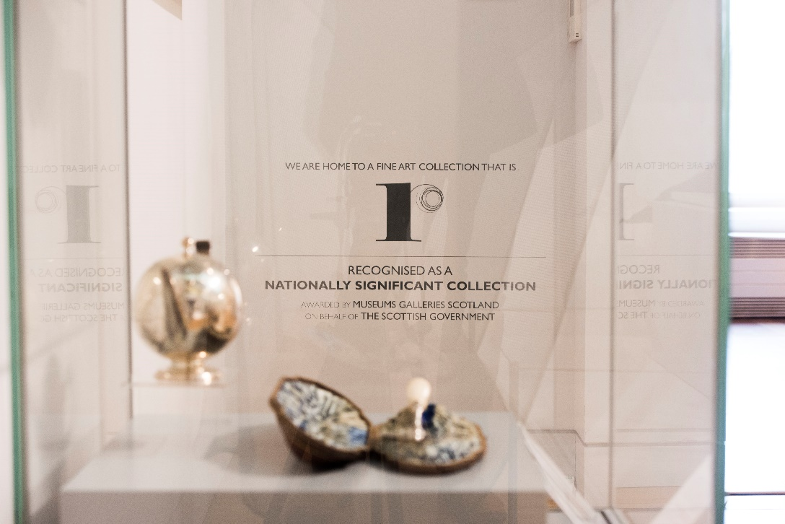

Logo being used in the gallery

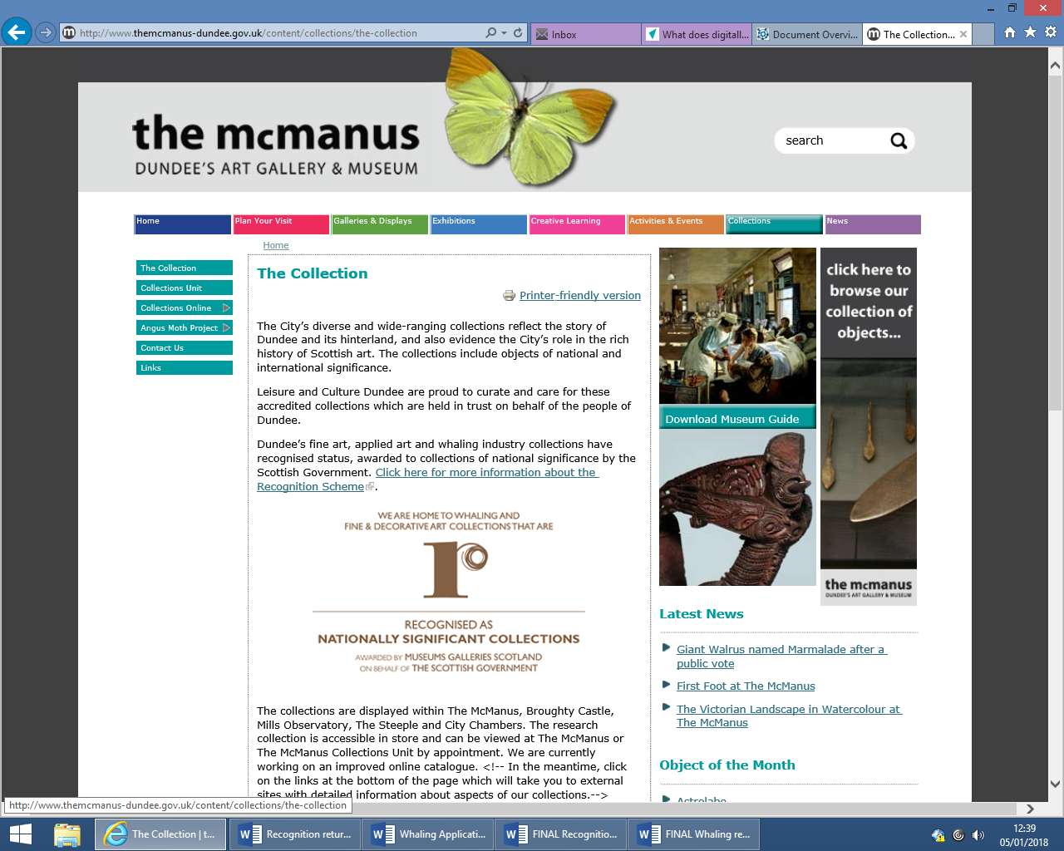

Logo being used on our website

[**http://www.mcmanus.co.uk/content/collections/the-collection**](http://www.mcmanus.co.uk/content/collections/the-collection)

1. **Loans from the Collection, and whether this changed since Recognition status was awarded.**

Dundee City Council and subsequently Leisure and Culture Dundee on Behalf of Dundee City Council have not received any loan enquiries/ requests for any material which are part of the Recognised Whaling Collection.

This however is across the museum services collections, the majority of loan requests are from the Fine Art collections and seldom from the Natural History, Social History, Archaeology or World Culture Collections. This in part could be to do with current world economic problems for costs of exhibitions, transport etc.

We have had a collections online catalogue since the re-opening of the McManus (2010) which initially launched with the material which was on permanent display. Material from the Dundee Whaling Collection project was added. Figures for visits have been good, however the collections management system was out of date and required immediate attention after 13 years’ service, was difficult to navigate and embedded in layers of website and therefore made it difficult to find information and navigate.

|  |  |
| --- | --- |
| Year | Visitor figures |
| 2016 | 21779 |
| 2017 | 22669 |

In 2016 we launched the new collections management system KEMU and we are currently in the process of releasing our new collections online. The new system will be easier to navigate and retrieve information.

This online presence could assist in the frequency of loan requests, however the subject itself can too limit the number of request.

Our Polar bear is on long term loan to Hull Museums, she has been there since 1975 and become a favourite in the city and has been given a name by the children of the city. This long term loan and the links with Hull go some way to show the major connections between the two ports at the height of the whaling industry. We will continue to support this long term loan with Hull Museums.

It does not appear that the demand for loans has risen since award.

1. **How engagement with the Collection has changed since Recognition status was awarded.**

The largest and most significant piece of engagement to the whaling collections is The McManus redevelopment. The Museum reopened again in 2010 with new galleries broken down thematically. The Tay whale was rehung in the Making of Modern Dundee Gallery which explores the history of Dundee from the 1850 to the present day, this became the centre piece of the story of the whaling and jute industries.

The Dundee Whaling History project also played a major role in the development of that gallery bringing together four partners across the city.

The whale remains an unofficial symbol of the museum and has been represented on the museums 150th anniversary bus advertising campaign. An instant symbol of the museum.

The demand for further information and access to the collections was given with the publication of the Ancestors in the Arctic book written by Malcolm Archibald. The publication still remains very popular and gives access to 136 pages of images and history.

Public enquiries, images requests and research requests still remain constant and proportionally high compared with the remainder of the collection. Many public enquiries lead into facilitated viewing of the collection either within the museum or at the museum collections unit.

In 2017, a large display of the city’s ship models collection was put on permanent display in a dedicated show case. It is not easy to ignore the impact that whaling had on the city and its shipping – a number of whaling ships and interpretation have been added to this display to give a full history of the city’s activity on the water.

Our Natural Science curator has developed due to demand a Tay whale talk which has been delivered to a number of organisations across Tayside and most recently as part of a Pecha Kucha style evening for the Abertay Historical Society.

Our most recent engagement with the whaling collections is the naming of the walrus, having received an overwhelming response to giving her a name we short listed the best and asked public opinion, again with an overwhelming response her name as chosen as Marmalade. Her recent showing has inspired a recent donation enquiry by a professor who would like to donate a walrus tusk specifically for handing to allow people to know what a walrus tusk feels like.

Proportionately, compared with the remainder of the collection, we tend to provide a greater engagement with the whaling collection than other areas of the social history collection.

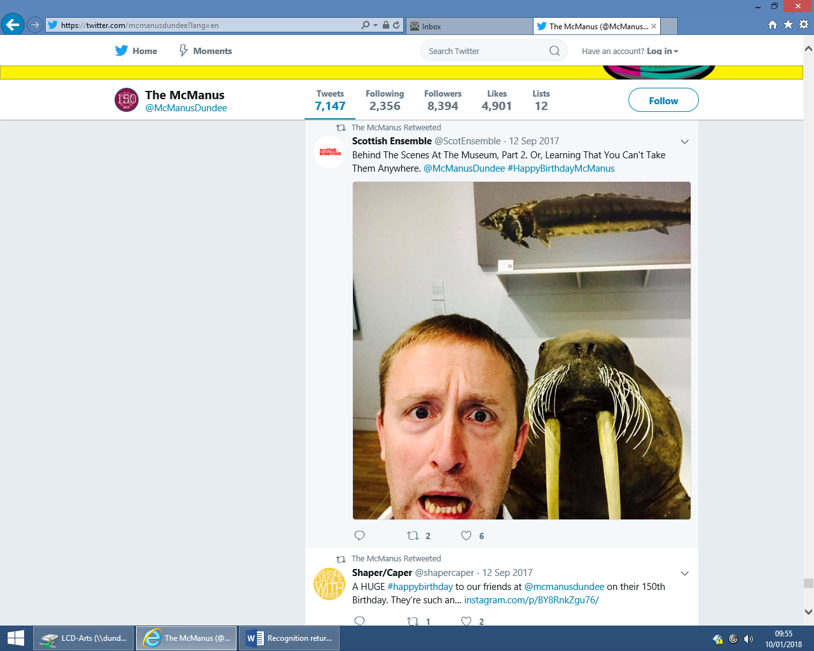

Public interactions with our collections

1. **The benefits Recognised status has brought for the Collection and/or the organisation;**

The obvious benefit of the scheme is the reputation to note that the city among its fully Accredited Museums has a number of collections Recognised by the Scottish Government as being Nationally significant is something that Dundee can remain proud. It not only builds confidence but reinforces the ambition of the city with its designation of UNESCO city of design and its bids to become Capital of Culture 2017 and European Capital of Culture 2023. There is also the benefit to have access to a ring fenced fund for the recognised collections.