Museum Development Manager - Learning, Engagement & Wellbeing
Full time (35 hours per week)
Starting salary £40,043 per annum
Permanent

Thank you for your interest in Museums Galleries Scotland (MGS). Please find below information about working at MGS; and a job description for the post of Museum Development Manager - Learning, Engagement & Wellbeing.

To apply:
- Please complete an application form, by downloading it from our website.

- Then submit your form via our online system at:
https://hr.breathehr.com/v/museum-development-manager-learning-46332

The deadline to apply is Monday 11th May at 9am.

Please use our application form, CVs will not be accepted. If our application form makes it difficult for you to apply and demonstrate your skills effectively, we would be happy to accept a video, audio or alternative application format. Please refer to the guidance on alternative application format to ensure your application will cover all the required information. If you would like to discuss an application in an alternative format, please contact us on the email below or call 0131 550 4197.
If you have any queries please email hr@museumsgalleriesscotland.org.uk, including the name of the post in the subject box.

Please note that interviews for this post are planned to take place on Thursday the 28th May. The format of the interview will be a task or presentation which we will send information about in advance (if relevant to the role) and a series of competency based questions.

Museums Galleries Scotland welcomes applications from all sections of the community and is an equal opportunities employer. We hold Living Wage and Investors in People Gold accreditation and are happy to talk flexible working. We will guarantee an interview to people with disabilities who meet the essential criteria in our person specification.

We will guarantee an interview to people with disabilities who meet the essential criteria in our person specification. Please note, we always make best efforts to implement this however there may be occasions where it is not practicable to interview all disabled people that meet the essential criteria for the job. For example if we receive a very high number of applications meeting this criteria. In this situation we will consider a reasonable alternative approach – for example setting a maximum number of interviews and ensuring that a proportion of interviews are offered to the disabled candidates who best meet the essential criteria for the job.

Please note that details supplied may be held in electronic and paper files for administration purposes only during the recruitment process. We retain recruitment files for six months following the date of interview, after which they are disposed of appropriately. You can find our privacy policy.

Working at Museums Galleries Scotland
Museums Galleries Scotland is the National Development Body for the Scottish museums sector. We’re here to support more than 452 museums and galleries, whether through strategic investment, advice, advocacy, skills development or other means. You can find out more about our objectives, business plan and day to day goals on our website: https://www.museumsgalleriesscotland.org.uk/about-us/
MGS currently has 47 staff. We have Gold Investors in People accreditation, are a Disability Confident Employer and a Living Wage Employer. MGS is striving to be an anti-racist organisation and more information on our commitment to this is here. We also aim to support museums and galleries to reach their climate and sustainability goals and our commitment to climate action can be found here.
Location
MGS is a hybrid working organisation with flexibility around working from home and the office. We have a modern open-plan office in central Edinburgh and we are set up for a range of flexible working options.
There is no expectation that staff will attend our office for any set number of days per week or per month. Depending on the role, we are also open to the option of ‘homeworker’ status where an employee is based at their home address.
The postholder may be required to attend certain events, in-person meetings and to make visits to museums as necessary. However, with most roles, we are open to discussing the frequency of this with the successful candidate.
We also hold quarterly ‘all staff’ meetings which we do expect everyone to attend in person wherever possible. Examples of recent meetings have included a trip to the Summerlee Museum of Scottish Industrial Life, Stirling Smith Art Gallery & Museum, Dunfermline Carnegie Library & Galleries and V&A Dundee and Dundee Discovery Point.
In order to carry out an effective induction, we consider it beneficial for the successful candidate to attend our Edinburgh office on your first day of work at MGS. We will provide you with a laptop and other equipment you require.
Hours of work
The normal full time working week is one of 35 hours Monday to Friday with a minimum unpaid lunch break of half an hour.
Annual leave
Annual leave entitlement for full-time employees is 25 working days plus 10 public holidays, rising to 30 days after 5 years’ continuous service. (Leave is calculated pro-rata for part-time employees.)
Pension
MGS employees will be automatically enrolled in the Lothian Pension Fund. This is a secure and valuable Local Government Pension Scheme designed to support your financial wellbeing. There is a generous employer contribution (19.4% in 2026-27) and your employee contribution rate is a set percentage of your pensionable pay. Find more information about the pension scheme.
Employee Assistance Programme
All employees have access to an Employee Assistance Programme offering support on a wide range of issues.
MGS is commited to progressive changes across our ways of working and to continuous improvement. We are proud to have achieved or signed up to the following organisational accreditations and commitments.

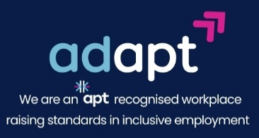

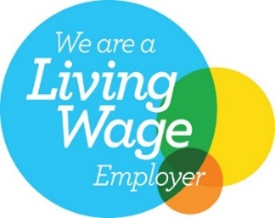
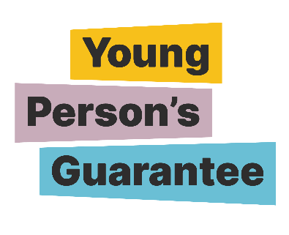


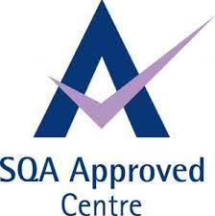
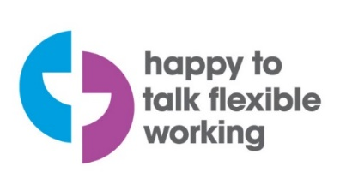



LGBT Youth Scotland Charter Mark
MGS has signed up for the LGBT Youth Scotland Chartermark accreditation programme which we are due to complete in April 2026.
The LGBT Charter is a programme that enables organisations to proactively include LGBTQ+ people in every aspect of work, including protecting staff and providing high quality services.

[Logos shown are for: Investors in People Gold, Happy to Talk Flexible Working, Living Wage Employer, Disability Confident Employer, Apt – Proud Partner in reducing the disability employment gap, Carbon Literate Organisation Gold, SQA Approved Centre, Young Person’s Guarantee, Modern Apprenticeships provider, Scottish Business Pledge.]

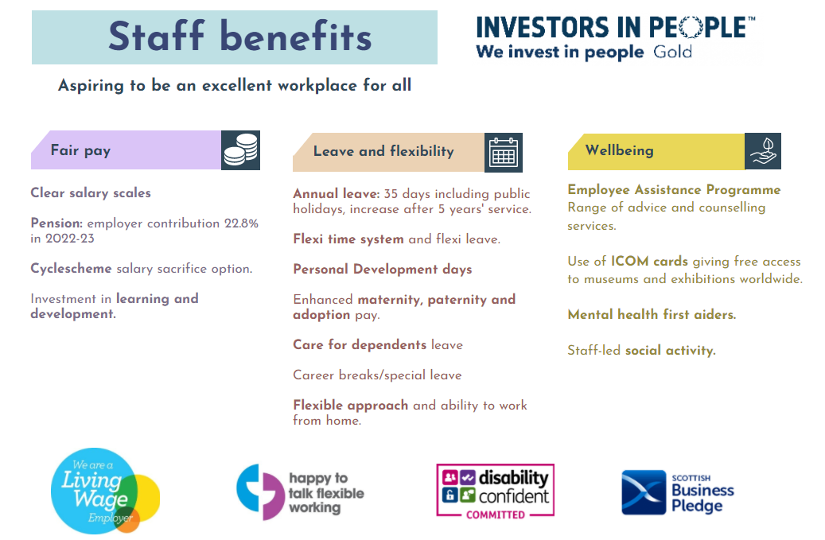

Pension: employer contribution 19.4% in 2024-25
About Museums Galleries Scotland
Museums Galleries Scotland (MGS) is the National Development Body for Scotland’s museum sector. We support museums and galleries through strategic investment, advice, workforce development and advocacy.

We are the lead body for the delivery of Scotland’s Museums and Galleries Strategy 2023-2030. Written with, and for, all of Scotland’s museums and galleries, the creation of the strategy has been a joint endeavour. This shared ownership will continue into the delivery of the strategy.

Strategy is central to all of MGS’s work. The strategy provides a framework for the sector and MGS to work to ensure the future relevance and resilience of the sector. It centres around three thematic strands of Connection, Resilience and Workforce.

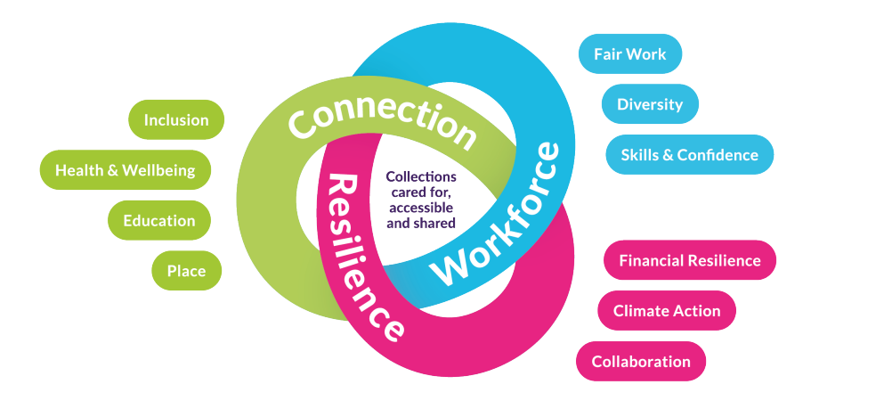

Museum Development Manager: Learning, Engagement & Wellbeing

Job description

Job information
- Line manager: Senior Museum Development Manager

- Team: Museum Development

- Full Time (35 hours hours per week)

- Permanent

- Location: Hybrid

Summary of Position
The Learning, Engagement and Wellbeing Manager works as part of the Museum Development team to facilitate and support development across the sector in line with the strategy for Scotland’s Museums and Galleries Strategy.

The strategy provides a framework for the sector and MGS to work to ensure the future relevance and resilience of the sector. It centres around three thematic strands of Connection, Resilience and Workforce.

This role requires someone is knowledgeable and passionate about the role of museums in society and has a broad understanding of the wider education and health and wellbeing contexts in Scotland. They will have the experience and knowledge to continue to build collaborative relationships, existing and new, and drive learning, engagement and wellbeing activities. You will actively champion MGS’s organisational behaviours both internally and externally.

This post will have a particular focus on the Education and Health & Wellbeing elements of the Connection strand of the strategy and will support the sector to deliver outcomes in these areas. For this exciting role, we are looking for someone who is passionate about the role museums have in delivering wider societal impact and working with sector colleagues across Scotland.

The postholder will support the interconnected nature of the strands through working collaboratively with staff across the MGS team working specifically with colleagues in the Museum Development and Skills teams, bridging work and working across strands to support and advocate for the museums and galleries sector in Scotland.

The postholder will be proactive in supporting existing partnerships and relationships and developing new ones. Driving key strategic learning and engagement activities, the postholder will be collaborative, consultative and responsive to their approach in working with others.

The postholder will be knowledgeable and experienced in the museum and heritage sector, and able to collect, analyse and act upon relevant feedback, research and data.

It is anticipated that the postholder will hold a supervisory and supportive role within the organisation, relating to their work priorities, and although there are currently no line management responsibilities, leadership qualities would be expected when coordinating and working within specific projects and priorities.

Relationship building is a key part of the role, and developing links with stakeholders, e.g. Education Scotland, Public Health Scotland, Developing the Young Workforce, and other key partners, will be fundamental to successful and positive outcomes.

OVERVIEW OF RESPONSIBILITIES

The mentioned tasks and responsibilities below constitute an overview and not an exhaustive list. Workload and priorities are ultimately determined by the annual MGS Operational Plan.

- Lead, develop and manage initiatives and programmes to support learning, health & wellbeing, engagement and skills outcomes, relevant to the role.

- Provide knowledge, advice and signposting to the sector relating to the Curriculum for Excellence, Health & Wellbeing, Community Engagement, Participatory Practice, Employability priorities – to inform relevant policies, sector standards and best practice guidelines that meet sector needs.

- Work collaboratively with partners and stakeholders to create opportunities for the sector and advocate for learning, engagement and wellbeing work.

- Support the delivery of the actions for MGS actions, detailed in Recommendation 5 of the Empire, Slavery and Scotland’s Museums Recommendations and support the sector to deliver theirs.
- Collect, analyse, evaluate evidence of sector impact and communicate this effectively internally and externally for advocacy purposes.
- Facilitate and develop networking opportunities for the sector, including previous forums (e.g. Blether Together and the Strategic Learning Forum) but also look for new opportunities relating to need (e.g. in the Health & Wellbeing area of work).

- Contribute to the development of projects, including identifying and securing external funding and aligning with the wider organisational and sector aims and priorities.

- Collaborate around skills-related activity within education settings, e.g. developing qualifications in school settings

- Manage staff if required, including contractors, consultants and sessional staff as appropriate.

- Support Grants and Accreditation scheme assessment when appropriate.

- Work with Head of Department to provide collaborative leadership of projects and programmes.

RELATIONSHIPS

- Build and nurture effective working relationships across the organisation and with external partners.
- Work fairly and with integrity and adapt style to different people, cultures and situations.
- Proactive attitude to seek new ways of working, knowledge, identify and seize opportunities to support the sector.
- Collaborate with other staff to support and deliver MGS projects and programmes, In particular, the Museum Development and Skills teams.
- Work with Comms and Marketing - to maximise reach and impact of resources and activities.
- Research – to develop new and utilise existing research and impact reporting.

- Work collaboratively to measure, assess and adapt ongoing work.

- Provide support and recognition to staff and understand the needs and concerns of the MGS team and wider sector.

Person Specification
The successful candidate will manifest our core values: collaboration, integrity, passion for museums, and courageousness.

WORK EXPERIENCE AND SKILLS
Essential
- Knowledge of the education systems in Scotland and awareness of the wider UK context

- Knowledge of best practice in informal museums learning practices, health & wellbeing approaches and engagement principles

- Experience working in or with museums or heritage organisations

- Project management – including development, delivery, allocation of resources and evaluation.

- Collaborative working – with internal colleagues and external stakeholders and partners.

- Development of joint programmes and activities (specifically relating to Education/Health & Wellbeing/Anti-Racism/Climate/Skills).

- Working with, and applying to, funders (also through collaborative approaches).
- Experience, or willingness to learn about anti-oppression approaches in museums and heritage settings.
- Monitoring and Evaluation best practice.

Preferred
- Developing and facilitating group sessions across organisations (i.e. external working groups/forums).

- Experience of supporting colleagues and external stakeholders to achieve shared outcomes.

- Working with consultants and contractors.

We work with staff to help everyone reach their potential in the workplace and welcome conversations with individuals about their needs, circumstances and aspirations.

HOW YOU WORK
MGS has a behavioural competency framework which describes how we expect people to go about their work day-to-day. Staff must demonstrate the following skills areas at an appropriate level:

• Works collaboratively
• Communicating with impact
• Respect, inclusion and integrity
• Effective decision-making
• Sector focus
• Drive for results
• Innovation, agility and building capability

All staff are expected to champion and help deliver MGS’s commitments to anti-racism and climate.

SPECIAL REQUIREMENTS - Travel – regionally will be required occasionally (estimated 25 days a year).

