Marketing and PR Officer
Part time (21 hours per week, worked flexibly across Monday to Friday)
Starting salary £31,292 per annum, pro rata (£18,775)
Maternity cover 12 months

Thank you for your interest in Museums Galleries Scotland (MGS). Please find below information about working at MGS; and a job description for the post of Marketing and PR Officer.

To apply:
- Please complete an application form, by downloading it from our website.

- Then submit your form via our online system at:
https://hr.breathehr.com/v/marketing-and-pr-officer-46454

The deadline to apply is 9am Friday 15th May 2026.

Please use our application form, CVs will not be accepted. If our application form makes it difficult for you to apply and demonstrate your skills effectively, we would be happy to accept a video, audio or alternative application format. Please refer to the guidance on alternative application format to ensure your application will cover all the required information. If you would like to discuss an application in an alternative format, please contact us on the email below or call 0131 550 4197.
If you have any queries please email hr@museumsgalleriesscotland.org.uk, including the name of the post in the subject box.

Please note that interviews for this post are planned to take place online, on Thursday 28th and Friday 29th May. The format of the interview will be a task or presentation which we will send information about in advance (if relevant to the role) and a series of competency based questions.

Museums Galleries Scotland welcomes applications from all sections of the community and is an equal opportunities employer. We hold Living Wage and Investors in People Gold accreditation and are happy to talk flexible working. We will guarantee an interview to people with disabilities who meet the essential criteria in our person specification.

We will guarantee an interview to people with disabilities who meet the essential criteria in our person specification. Please note, we always make best efforts to implement this however there may be occasions where it is not practicable to interview all disabled people that meet the essential criteria for the job. For example if we receive a very high number of applications meeting this criteria. In this situation we will consider a reasonable alternative approach – for example setting a maximum number of interviews and ensuring that a proportion of interviews are offered to the disabled candidates who best meet the essential criteria for the job.

Please note that details supplied may be held in electronic and paper files for administration purposes only during the recruitment process. We retain recruitment files for six months following the date of interview, after which they are disposed of appropriately. You can find our privacy policy.
Working at Museums Galleries Scotland
Museums Galleries Scotland is the National Development Body for the Scottish museums sector. We’re here to support more than 452 museums and galleries, whether through strategic investment, advice, advocacy, skills development or other means. You can find out more about our objectives, business plan and day to day goals on our website: https://www.museumsgalleriesscotland.org.uk/about-us/
We are a forward-facing and inclusive organisation, committed to the ongoing development of a positive and supportive culture for our team.

MGS currently has 47 staff. We have Gold Investors in People accreditation, are a Disability Confident Employer and a Living Wage Employer. MGS is striving to be an anti-racist organisation and more information on our commitment to this is here. We also aim to support museums and galleries to reach their climate and sustainability goals and our commitment to climate action can be found here.
Location
MGS is a hybrid working organisation with flexibility around working from home and the office. We have a modern open-plan office in central Edinburgh and we are set up for a range of flexible working options.
There is no expectation that staff will attend our office for any set number of days per week or per month. Depending on the role, we are also open to the option of ‘homeworker’ status where an employee is based at their home address.
The postholder may be required to attend certain events, in-person meetings and to make visits to museums as necessary. However, with most roles, we are open to discussing the frequency of this with the successful candidate.
We also hold quarterly ‘all staff’ meetings which we do expect everyone to attend in person wherever possible. Examples of recent meetings have included a trip to the the Summerlee Museum of Scottish Industrial Life, Stirling Smith Art Gallery & Museum, Dunfermline Carnegie Library & Galleries and V&A Dundee and Dundee Discovery Point.
In order to carry out an effective induction, we consider it beneficial for the successful candidate to attend our Edinburgh office on your first day of work at MGS. We will provide you with a laptop and other equipment you require.
Hours of work
The normal full time working week is one of 35 hours Monday to Friday with a minimum unpaid lunch break of half an hour.

Annual leave
Annual leave entitlement for full-time employees is 25 working days plus 10 public holidays, rising to 30 days after 5 years’ continuous service. (Leave is calculated pro-rata for part-time employees.)
Pension
MGS employees will be automatically enrolled in the Lothian Pension Fund. This is a secure and valuable Local Government Pension Scheme designed to support your financial wellbeing. There is a generous employer contribution (19.4% in 2025-26) and your employee contribution rate is a set percentage of your pensionable pay. Find more information about the pension scheme.
Employee Assistance Programme
All employees have access to an Employee Assistance Programme offering support on a wide range of issues.
MGS is commited to progressive changes across our ways of working and to continuous improvement. We are proud to have achieved or signed up to the following organisational accreditations and commitments.

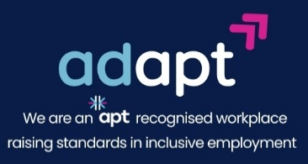

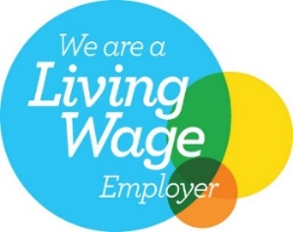
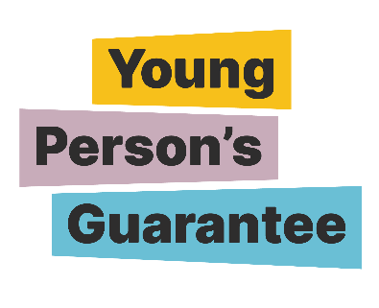


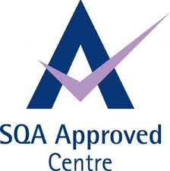
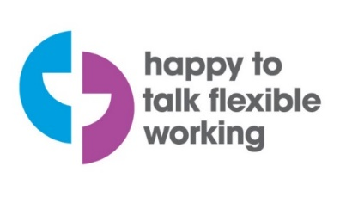



LGBT Youth Scotland Charter Mark
MGS has signed up for the LGBT Youth Scotland Chartermark accreditation programme which we are due to complete in April 2026.
The LGBT Charter is a programme that enables organisations to proactively include LGBTQ+ people in every aspect of work, including protecting staff and providing high quality services.

[Logos shown are for: Investors in People Gold, Happy to Talk Flexible Working, Living Wage Employer, Disability Confident Employer, Apt – Proud Partner in reducing the disability employment gap, Carbon Literate Organisation Gold, SQA Approved Centre, Young Person’s Guarantee, Modern Apprenticeships provider, Scottish Business Pledge.]

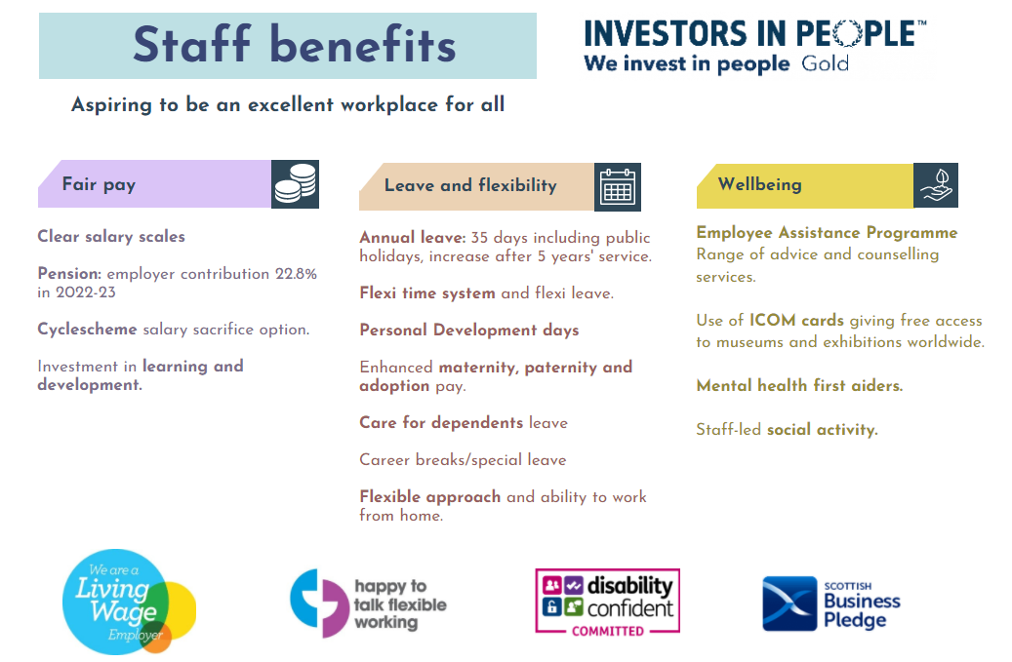

Pension: employer contribution 19.4% in 2024-25
About Museums Galleries Scotland
Museums Galleries Scotland (MGS) is the National Development Body for Scotland’s museum sector. We support museums and galleries through strategic investment, advice, workforce development and advocacy.

We are the lead body for the delivery of Scotland’s Museums and Galleries Strategy 2023-2030. Written with, and for, all of Scotland’s museums and galleries, the creation of the strategy has been a joint endeavour. This shared ownership will continue into the delivery of the strategy.

Strategy is central to all of MGS’s work. The strategy provides a framework for the sector and MGS to work to ensure the future relevance and resilience of the sector. It centres around three thematic strands of Connection, Resilience and Workforce.

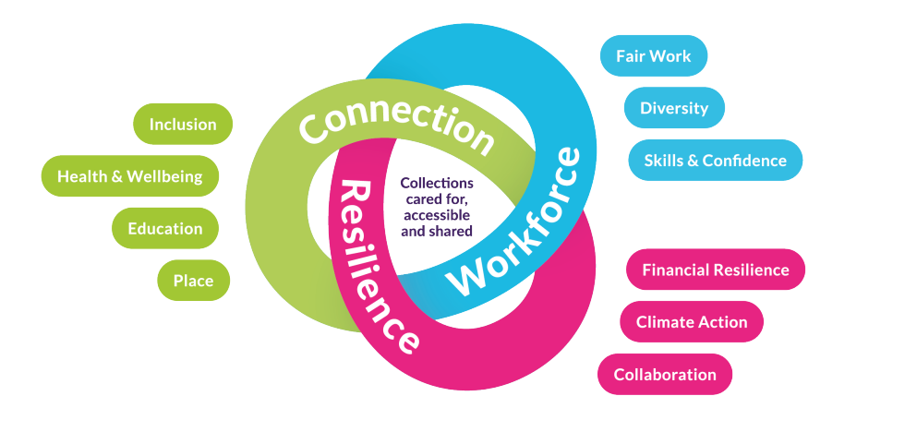

Marketing and PR Officer

Job description

Job information
- Line manager: Marketing and Communications Manager

- Team: Marketing and Communications

- Part time (21 hours per week, worked flexibly across Monday to Friday)

- Maternity cover for 12 months

- Location: Hybrid

Summary of Position
This is an exciting time to join MGS as we embark on year two of Museum Futures, a programme created to accelerate collaboration, innovation, and organisational sustainability within the sector. It’s also the final year of Delivering Change, a collaborative programme to enable organisations to restructure based on anti-oppressive principles. Alongside this, we are working to strengthen and expand the impact of our advocacy work.

As Marketing and PR Officer, you will play a key role in delivering communications across these programmes, as well as a range of MGS projects.

A key support position within a busy Marketing and Communications team, you will contribute to and champion an integrated approach across the full marketing and communications mix. With a strong awareness of MGS and our key audiences, you will help implement relevant strategies, processes and activity that raise the profile of both Scotland’s museums and MGS, while also sharing best practice to support sector development.
The Marketing and PR Officer will be an experienced communicator with a positive, ’can-do’ attitude, who understands how to tailor activity to reach different audiences and is comfortable working with the media. Strong communication skills are essential, including the ability to give and receive constructive feedback.
The role also requires excellent organisational and administrative skills, with close attention to detail. The ability to multitask and demonstrate enthusiasm and initiative constitutes a natural part of the job.

OVERVIEW OF RESPONSIBILITIES
- Support the planning and delivery of marketing, PR and advocacy plans and initiatives to meet organisational objectives.
- Develop digital/online content, including copy for website such as news stories, blogs, or case studies.
- Support the planning and delivery of MGS media announcements and photocalls.
- Shared responsibility for media monitoring, sharing of relevant news items and reporting
- Work with third party contractors and suppliers.
- Share marketing best practice and advice with the sector, to enhance knowledge of this area.
- Provide administrative support relevant to the role.
The above-mentioned tasks and responsibilities constitute an overview and not an exhaustive list. Workload and priorities are ultimately determined by the annual MGS Operational Plan.

RELATIONSHIPS
- Build and nurture effective working relationships across the organisation
- Proactive attitude to seek new knowledge, identify and seize learning opportunities
- Collaborate on joint projects and take part in relevant working groups
- A positive working relationship within the MGS team to ensure optimum impact
- Work fairly and with integrity and adapt style to different people, cultures and situations
- Responsible for maintaining day-to-day relations with other parts of the business relevant to the Marketing and Communications effort

Person Specification
The successful candidate will manifest our core values: collaboration, integrity, passion for museums, and courageousness.

WORK EXPERIENCE AND SKILLS
Essential
- Minimum two years’ experience of working in a communications role
- Excellent communication skills, including written skills
- Experience of undertaking press engagement activity, developing press releases and handling media enquiries
- Experience of delivering media announcements across multiple communications channels
- Good understanding of on and offline copywriting and digital marketing
- Good organisational/administrative skills
- Microsoft Office and other relevant software knowledge
Preferred
- Qualification in PR, Marketing or related area at SQA level 4 or above
- Communications experience within the Arts/Cultural/Heritage sector
- Experience of shared management of small to mid-scale projects, delivered on time and to budget
- Experience of evaluating communication campaign activity
- Interest in museums and the wider heritage and cultural sector

We work with staff to help everyone reach their potential in the workplace and welcome conversations with individuals about their needs, circumstances and aspirations.

HOW YOU WORK
MGS has a behavioural competency framework which describes how we expect people to go about their work day-to-day. Staff must demonstrate the following skills areas at an appropriate level:

• Works collaboratively
• Communicating with impact
• Respect, inclusion and integrity
• Effective decision-making
• Sector focus
• Drive for results
• Innovation, agility and building capability
This role requires someone who collaborates well and promotes this approach across teams, can make effective decisions following appropriate criteria, organises and plans work effectively, readily contributes ideas, and conveys information clearly.

All staff are expected to champion and help deliver MGS’s commitments to anti-racism and climate.

SPECIAL REQUIREMENTS –
The Marketing and Communications team meets in person once a month in the office in central Edinburgh, so it is preferred that the postholder be able to attend this in person. (Where circumstances may be a barrier to this, we are open to a conversation about flexibility.)

