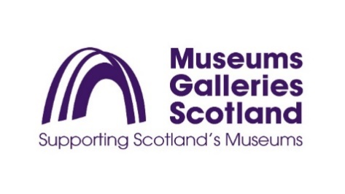
EQUAL OPPORTUNITIES MONITORING FORM
Museums Galleries Scotland (MGS) has an equal opportunities policy. MGS is monitoring details of applicants' sex, ethnic origin, marital status, age and disability so that we can ensure that our recruitment is fair and does not discriminate against any group. We would be grateful therefore if you would complete this form.
The information provided in the monitoring form is not used in the selection process. It is used purely to monitor the effectiveness of MGS’s Equal Opportunities Policy.
The selection and interview panels do not see the information contained in these monitoring forms.
Where did you hear about this vacancy?
MGS Website |  | Creative Scotland |  | Goodmoves |  | Word of mouth

Social Media (please specify) |  | Anywhere else (please specify)

Prefer not to say

Age
16-24 |  | 25-29 |  | 30-34 |  | 35-39 |  | 40-44
45-49 |  | 50-54 |  | 55-59 |  | 60-64 |  | 65+
Prefer not to say

Gender
Female |  | Intersex |  | Male |  | Non-binary |  | Prefer not to say

Is the gender you identify with the same as your gender registered at birth?
Yes |  | No |  | Prefer not say

Are you married or in a civil partnership?
Yes |  | No |  | Prefer not to say

Sexual orientation
Bisexual |  |  | Gay |  | Heterosexual |  | Lesbian |  | Other
Prefer not to say

What is your ethnicity?
Ethnic origin is not about nationality, place of birth or citizenship. It is about the group to which you perceive you belong. Please select the appropriate group.
Arab ☐
Asian/Asian British - Any other Asian background, (please state below)
Asian/Asian British - Bangladeshi ☐
Asian/Asian British - Chinese ☐
Asian/Asian British - Indian ☐
Asian/Asian British - Pakistani ☐
Black/ Black British - African ☐
Black/ Black British - Caribbean ☐
Black/Black British - Any other Black background (please state below)
Any other mixed background, (please state below)
Mixed/multiple ethnic groups - White and Asian ☐
Mixed/multiple ethnic groups - White and Black African ☐
Mixed/multiple ethnic groups - White and Black Caribbean ☐
White - British ☐
White - English ☐
White - Gypsy or Irish Traveller ☐
White - Irish ☐
White - Northern Irish ☐
White - Scottish ☐
White - Welsh ☐
Any other white background, (please state below)
Any other ethnic group, (please state below)
Prefer not to say ☐
If you have selected any category above giving the option to state more information, please use this space to do so.

We welcome applications from people with disabilities and will make reasonable adjustments necessary for candidates to participate on equal terms in the recruitment process and fulfil the duties of the post if selected. We encourage staff and managers to have ongoing conversations about individual needs.
Museums Galleries Scotland would be grateful if you could provide the following information. You do not have to disclose any disability, but if you do, you will be protected under the terms of the Equality Act 2010 and will allow Museums Galleries Scotland to make any reasonable adjustments necessary to the recruitment process and to provide any support necessary for you to fulfil the duties of the job.
MGS will guarantee an interview to people with disabilities who meet the essential criteria in our person specification. To enable this to happen, the information here will be referred to after all application forms have been assessed against the job criteria, to inform the interview shortlist.
Please note, we always make best efforts to implement this however there may be occasions where it is not practicable to interview all disabled people that meet the essential criteria for the job. For example if we receive a very high number of applications meeting this criteria. In this situation we will consider a reasonable alternative approach – for example setting a maximum number of interviews and ensuring that a proportion of interviews are offered to the disabled candidates who best meet the essential criteria for the job.
Do you consider yourself to be a disabled person under the terms of the Equality Act (2010)?
Yes |  | No |  |  | Prefer not to say

If yes, what is the nature of your disability?

Do you have any disability-related access requirements? (e.g. adjustments to enable you to attend interview whether online or in person, information in an alternative format or other adjustments?)

