Operations and Compliance Assistant
Full time (35 hours per week)
Starting salary £26,115 per annum
Permanent
Location: Hybrid, with some requirement for office working in Edinburgh

While this role is designed as a full-time post, we would be open to considering a minimum of 28 hours per week. The postholder will ideally work a Friday to ensure team cover across the week.

Thank you for your interest in Museums Galleries Scotland (MGS). Please find below information about working at MGS; and a job description for the post of Operations and Compliance Assistant.

To apply:
- Please complete an application form, by downloading it from our website.

- Then submit your form via our online system at:
https://hr.breathehr.com/v/operations-and-compliance-assistant-48505

The deadline to apply is 9am on Wednesday 9th September 2026.

Please use our application form, CVs will not be accepted. If our application form makes it difficult for you to apply and demonstrate your skills effectively, we would be happy to accept a video, audio or alternative application format. Please refer to the guidance on alternative application format to ensure your application will cover all the required information. If you would like to discuss an application in an alternative format, please contact us on the email below or call 0131 550 4197.
If you have any queries please email hr@museumsgalleriesscotland.org.uk, including the name of the post in the subject box.

Please note that interviews for this post are planned to take place online, on Tuesday 22nd and/or Wednesday 23rd September 2026. The format of the interview will be a task or presentation which we will send information about in advance (if relevant to the role) and a series of competency based questions.

Museums Galleries Scotland welcomes applications from all sections of the community and is an equal opportunities employer. We hold Living Wage and Investors in People Gold accreditation and are happy to talk flexible working.

We will guarantee an interview to people with disabilities who meet the essential criteria in our person specification. Please note, we always make best efforts to implement this however there may be occasions where it is not practicable to interview all disabled people that meet the essential criteria for the job. For example if we receive a very high number of applications meeting this criteria. In this situation we will consider a reasonable alternative approach – for example setting a maximum number of interviews and ensuring that a proportion of interviews are offered to the disabled candidates who best meet the essential criteria for the job.

Please note that details supplied may be held in electronic and paper files for administration purposes only during the recruitment process. We retain recruitment files for six months following the date of interview, after which they are disposed of appropriately. You can find our privacy policy.
Working at Museums Galleries Scotland
Museums Galleries Scotland is the National Development Body for the Scottish museums sector. We’re here to support more than 450 museums and galleries, whether through strategic investment, advice, advocacy, skills development or other means. You can find out more about our objectives, business plan and day to day goals on our website: https://www.museumsgalleriesscotland.org.uk/about-us/
We are a forward-facing and inclusive organisation, committed to the ongoing development of a positive and supportive culture for our team.

MGS currently has 47 staff. We have Gold Investors in People accreditation, are a Disability Confident Employer and a Living Wage Employer. MGS is striving to be an anti-racist organisation and more information on our commitment to this is here. We also aim to support museums and galleries to reach their climate and sustainability goals and our commitment to climate action can be found here.
Location
MGS is a hybrid working organisation with flexibility around working from home and the office. We have a modern open-plan office in central Edinburgh and we are set up for a range of flexible working options.
Although this is a hybrid role, regular office attendance in Edinburgh will be required for effective office and facilities support – a minimum of two days a week. This will be agreed with the line manager.
The postholder may be required to attend certain events, in-person meetings and to make visits to museums as necessary. However, with most roles, we are open to discussing the frequency of this with the successful candidate.
We also hold quarterly ‘all staff’ meetings which we do expect everyone to attend in person wherever possible. Examples of recent meetings have included a trip to the the Summerlee Museum of Scottish Industrial Life, Stirling Smith Art Gallery & Museum, Dunfermline Carnegie Library & Galleries and V&A Dundee and Dundee Discovery Point.
In order to carry out an effective induction, we consider it beneficial for the successful candidate to attend our Edinburgh office on your first day of work at MGS. We will provide you with a laptop and other equipment you require.
Hours of work
The normal full time working week is one of 35 hours Monday to Friday with a minimum unpaid lunch break of half an hour.

Annual leave
Annual leave entitlement for full-time employees is 25 working days plus 10 public holidays, rising to 30 days after 5 years’ continuous service. (Leave is calculated pro-rata for part-time employees.)
Pension
MGS employees will be automatically enrolled in the Lothian Pension Fund. This is a secure and valuable Local Government Pension Scheme designed to support your financial wellbeing. There is a generous employer contribution (19.4% in 2026-27) and your employee contribution rate is a set percentage of your pensionable pay. Find more information about the pension scheme.
Employee Assistance Programme
All employees have access to an Employee Assistance Programme offering support on a wide range of issues.
MGS is commited to progressive changes across our ways of working and to continuous improvement. We are proud to have achieved or signed up to the following organisational accreditations and commitments.

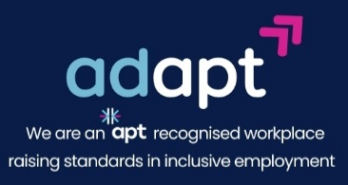

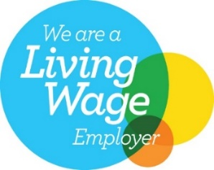



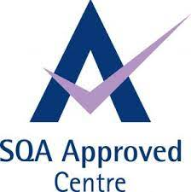




We are also delighted that Museums Galleries Scotland have recently passed the LGBT Charter (awarded by LGBT Youth Scotland) at Silver level.

[Logos shown are for: Investors in People Gold, Happy to Talk Flexible Working, Living Wage Employer, Disability Confident Employer, Apt – Proud Partner in reducing the disability employment gap, Carbon Literate Organisation Gold, SQA Approved Centre, Young Person’s Guarantee, Modern Apprenticeships provider, Scottish Business Pledge.]

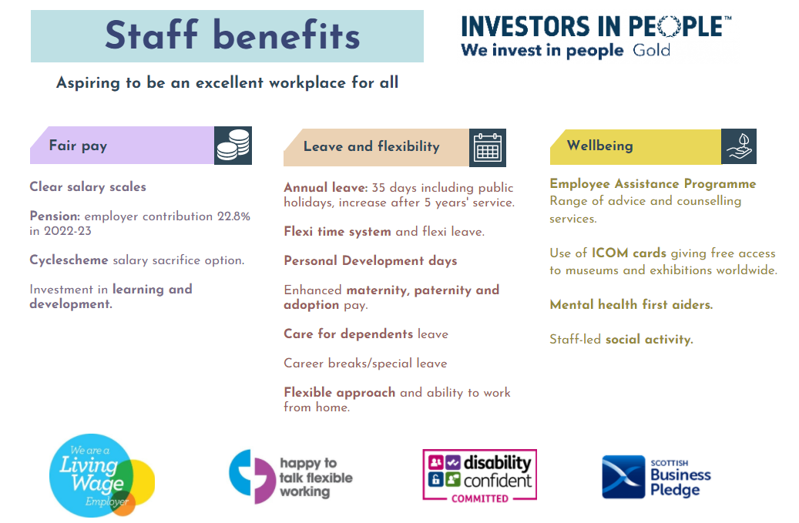

Pension: employer contribution 19.4 in 2026-27
About Museums Galleries Scotland
Museums Galleries Scotland (MGS) is the National Development Body for Scotland’s museum sector. We support museums and galleries through strategic investment, advice, workforce development and advocacy.

We are the lead body for the delivery of Scotland’s Museums and Galleries Strategy 2023-2030. Written with, and for, all of Scotland’s museums and galleries, the creation of the strategy has been a joint endeavour. This shared ownership will continue into the delivery of the strategy.

Strategy is central to all of MGS’s work. The strategy provides a framework for the sector and MGS to work to ensure the future relevance and resilience of the sector. It centres around three thematic strands of Connection, Resilience and Workforce.

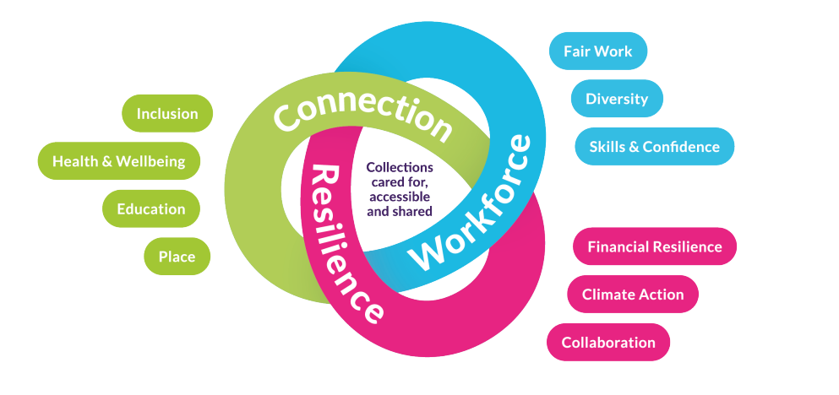

Operations and Compliance Assistant

Job description

Job information
- Line manager: Corporate Officer

- Team: Resources and Skills

- Full time - 35 hours per week

- Location: Hybrid, with some requirement for office working in Edinburgh

- Date reviewed: August 2026

SUMMARY OF POSITION
The Operations and Compliance Assistant provides administrative and operational support to ensure smooth delivery and ongoing development of our business and administration processes.
With a varied workload, this role is part of a Resources team with a strong focus on business improvement, delivering core activities which support
sustainability across the organisation and model the practices we want to see across the sector.
The Operations and Compliance Assistant brings strong organisational and administrative skills and a collaborative approach, a positive, can-do attitude, and an interest in supporting and improving processes. A clear and effective communicator, they act as a point of connection across teams in a fast-paced environment. This role gives an opportunity to be involved in a range of projects and programmes alongside day-to-day office administration.

OVERVIEW OF RESPONSIBILITIES
- Support Resources and Skills team colleagues across a range of areas and help deliver business improvement activities.
- Support all aspects of office administration and facilities including ordering supplies, managing equipment and liaising with IT support.
- Support finance processes including raising purchase orders, making card payments, and liaising with colleagues and suppliers.
- Assist staff with travel arrangements.
- Be a first point of contact for general enquiries via email and telephone.
- Deliver administrative processes which support the compliance of the MGS SQA Assessment Centre.
- Provide occasional administrative support for projects, programmes and meetings/events and be a point of connection across the organisation.
- Create and maintain resources and documents
- Maintain records and prepare data to support compliance and reporting.
- Work with colleagues across the organisation to align MGS practices to the National Strategy, contribute to collaborative action plans, and support development of good practice in the sector.
The above-mentioned tasks and responsibilities constitute an overview and not an exhaustive list. Workload and priorities are ultimately determined by the annual MGS Operational Plan.

RELATIONSHIPS
- Build and nurture effective working relationships across the organisation
- Collaborate with other staff to support and deliver MGS projects and programmes
- Work fairly and with integrity and adapt style to different people, cultures and situations
- This role works closely with the Resources and Skills team, in particular the Corporate Officer, as well as supporting others across the organisation

Person Specification

The successful candidate will manifest our core values: collaboration, integrity, passion for museums, and courageousness.

EXPERIENCE AND SKILLS
Essential
- Strong administrative and organisational skills across a varied workload
- Experience supporting a range of business operations and processes
- Experience supporting compliance areas
- People-focused and collaborative approach
- Attention to detail
- Working with data (written and numerical) and documents
- Strong customer focus and ability to communicate positively with a range of people
- Clear and effective written communication skills
- Problem solving, using initiative and a positive approach to change
- Prioritising own workload
- Confident using MS Office and a range of digital platforms

Preferred

- Experience delivering administrative support in an office environment
- Experience supporting finance processes
- Ability to identify and implement improved ways of working
- Organising travel
- Creating templates and resources

We work with staff to help everyone reach their potential in the workplace and welcome conversations with individuals about their needs, circumstances and aspirations.

HOW YOU WORK
MGS has a behavioural competency framework which describes how we expect people to go about their work day-to-day. Staff must demonstrate the following skills areas at an appropriate level:
- Works collaboratively
- Communicating with impact
- Respect, inclusion and integrity
- Effective decision-making
- Sector focus
- Drive for results
- Innovation, agility and building capability

In particular this role requires someone who organises and plans work effectively, collaborates well and promotes this approach across teams, can make effective decisions following appropriate criteria, readily contributes ideas and willingly adapts working practices to support changes.
All staff are expected to champion and help deliver MGS’s commitments to anti-racism and climate action.

Special Requirements
Although this is a hybrid role, regular office attendance in Edinburgh will be required for effective office and facilities support – a minimum of two days a week. This will be agreed with the line manager. The office is centrally located with excellent public transport links.

